DIGITAL HAPPENINGS #21
(April 2014)
By W0NAC (“Matt”)
It’s very gratifying to see new people joining in the fun and challenge of operating digital. New to digital are the mobile team of KG5UZ/KJ5PQ (Mike & Cheryl) who have been putting out many counties all over Texas on 3-4 digital modes. Also new this month is KC3X (Hollis) who just got his fixed station set up for digital ops and is now “going great guns!”. Also heard during April on digital were WB0TEV (Paul) who put out several TX counties on RTTY, KW1DX (Dave) in ME, and WY7FD (Dwayne – Not a County Hunter) on RTTY in Crook, WY.
Then, there was that monumental trip just completed by N6PDB/WA6OCV (Dennis & Susan) where they drove their RV all the way from CA to GA and back to CA putting out close to 250 counties on 3 – 4 digital modes. Their trip was a real boon to many county hunters and filled a lot of holes for the USA – Digital Award and the 5 – Mode award! They deserve many kudos from all of us for their unselfish efforts on our behalf! Dennis reports that he and Susan had a great time on the trip and were especially grateful to N1API, W4YDY, K5GE, and WB2ABD for sticking with them throughout the entire trip making sure that they completed Master Platinum transmitted counties and 3 new modes in all 250 counties.
Sharon and I are planning a trip through Alaska on the way to the National Convention in July. While there, we hope to put out all 4 Judicial Districts on SSB, CW and at least 4 Digital Modes. If our plans work out OK, we will publish the details for the trip on the K3IMC site and by email.
Now, on to the main topic for this month.

Compatibility Issues When Making RTTY Contacts:
First Some History
RTTY is the 2nd oldest digital mode in use today (the oldest is CW). Landline teleprinter operation began in 1849 between Philadelphia and New York City. In 1874, a man named Emile Baudot designed the five unit code (Baudot code) that is still in use today. Radioteletype (RTTY) was first successfully tested by the Navy between an airplane and a ground station in 1922. Commercial RTTY systems were in active service between San Francisco and Honolulu as early as 1932. The US Military used RTTY from the 1930’s and expanded this usage during World War II. Almost all of these RTTY systems used mechanical teleprinters until the 1980’s when they were replaced by computers running teleprinter emulation software.
Amateur use of RTTY began after World War II when obsolete, but usable Teletype Model 26 equipment became available from commercial operators. The first two-way amateur radioteletype QSO of record took place in May 1946 between W2AUF and W2BFD. The first RTTY contest (“RTTY Sweepstakes Contest”) took place in November 1953. The ARRL started issuing WAC RTTY certificates in 1969 and DXCC RTTY Awards in 1976. Today, many RTTY enthusiasts have moved on to more modern digital modes (like PSK and MFSK), but many hams and DXpeditions still use RTTY today. Also, there are many RTTY contests throughout the year. For county hunters, RTTY contests can be an excellent source of new counties for the USA – Digital Award and new modes for the 5 – Mode Award. By the way, if you have never heard a RTTY signal, click on the following and download the file to your desktop: https://dl.dropboxusercontent.com/u/26171574/RTTY.ogg . Once the file “RTTY.ogg” is on your desktop, just run it to listen.
RTTY Signal characteristics:
A RTTY signal begins with a series of ON (“Mark”) and OFF (“Space”) pulses which represent the various letters, numbers, and control characters in the 5 bit Baudot code. Unlike the 8 bit ASCII code which can code 256 characters, the 5-bit Baudot code can only be used to represent 26 characters plus 6 control codes. One of these control characters (“FIGS”) is used before a string of text to allow a 2nd set of 26 characters (10 numbers plus 16 punctuation marks). Another control code (“LTRS”) is used to shift back to the first set.
These ON and OFF pulses are then used to either directly modulate the frequency of an RF carrier or to modulate the frequency of an audio tone which is injected into the pass band of a transmitter configured for USB or LSB. The direct method is called FSK (Frequency Shift Keying) and the second is called AFSK (Audio Frequency Shift Keying). Some purists believe FSK is the only way to go, but both methods produce identical signals if used correctly. It should be noted, however, that AFSK is subject to being over-driven if the input audio signal is too strong (just like PSK) and will produce a distorted signal if driven into non-linear operation.
What is Polarity?
Here is where it can get confusing! In FSK there are two frequencies, conventionally called “Mark” and “Space”. In amateur RTTY, the mark frequency is (by convention) the higher of the two RF frequencies and RTTY signals are transmitted on LSB. If you transmit with the opposite polarity, you are said to be transmitting “upside down”. If the person receiving your signal has his software set for normal polarity, your signal will show as gibberish on his screen. To solve this problem, either the sender has to reverse the polarity of their transmitted signal or the receiver has to reverse their receive polarity. If you are using FSK you can usually control the transmit and receive polarity independently, but when using AFSK software (like Fldigi), both transmit and receive polarity change at the same time. If you are decoding gibberish from another RTTY signal, you can quickly test for them being upside down by clicking on the “Rv” button at the bottom right of the screen (below).
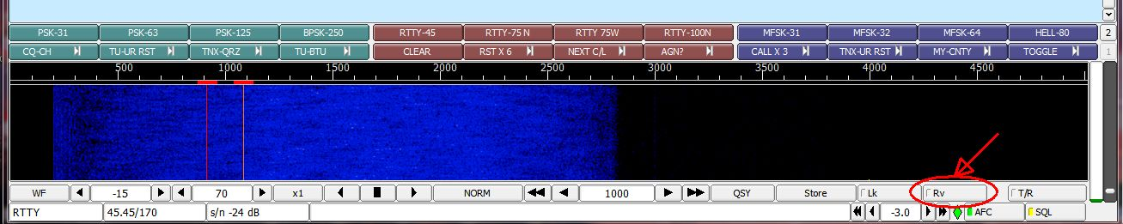
The “Rv” button toggles between two states - the normal (unreversed) as shown above and reversed (not shown) with the light ON at the left end of the button.
Fldigi handles default polarity a bit differently. First, the operator must set his transceiver to USB for all digital modes including RTTY. The Fldigi software then sets the transmit and receive polarities so that they are correct for other amateur signals using LSB. Naturally, the polarities are also correct for other people using Fldigi on USB. What this means is that you can use the default settings for Fldigi to both work RTTY contests (where most are probably transmitting on LSB) and mobile county hunters who are also using Fldigi on USB.
Fldigi Error:
An earlier release of Fldigi contained an error which caused improper configuration of the RTTY-45 mode when using the RTTY-45 MODEM Tag in a Macro Text. A message was sent to my digital list, but I need to repeat the cure for this problem here for anyone I may have missed. Simply stated, you need to:
1) Be sure you have updated to the latest version of Fldigi (Version 3.21.81 or later). You can get it from the following link: http://www.w1hkj.com/download.html .
2) If you have any macro files with macro buttons that select the RTTY-45 mode, you need to update the Macro Text for that macro button using the Modem Tag from the latest version of Fldigi as shown below:
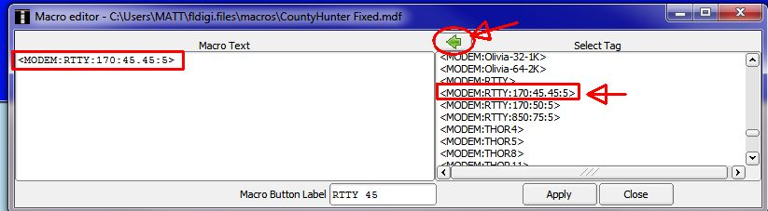
Pull up the Macro Editor by right clicking on the macro button you wish to edit, and then delete everything in the left box (Macro Text). Then scroll down in the Select Tag box until you see the Tag indicated and select it with a left click. Next, left click on the left pointing arrow at the top to move the Tag into the Macro Text box. Finally, click on “Apply”, then “Close”, and test your modified macro button by left clicking on it. You should see exactly the following near the lower left corner of your screen:
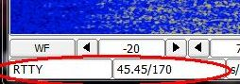
You need to repeat this process for every macro file that has a RTTY-45 macro button.
The updated Table 3 is given below:
How To Get Your 5 – Mode Statistics Updated:
Several past Digital Happenings articles have given detailed instructions on a new and easy way to update your digital statistics for Table 3 by using a small program called “Digital Report Utility”. This new program will create a report for you showing your progress for both the USA – Digital and the 5 – Mode Awards and email it to W0NAC. Instead of repeating these instructions every month I have included them in a Microsoft Word document that you can download by clicking on the following link: https://dl.dropboxusercontent.com/u/26171574/Happenings/5%20Mode%20Update.doc

Further comments on RTTY
Most digital county hunters seem to have settled on RTTY-45 as one of the 3 or 4 modes they use when putting out a county or county line. RTTY-45 is certainly the most popular RTTY sub-mode used by amateurs all over the world, but let me suggest that RTTY-45 may not be the best choice for digital county hunting. First, although a 45.45 baud rate is supposed to be the equivalent of 60 WPM (words per minute), in real world tests it comes out closer to 55 WPM. PSK-63 (one of our other popular digital modes) clocks in at almost 70 WPM. After putting out a county using PSK-63, the slower speed of RTTY-45 is definitely noticeable and you find yourself getting a little frustrated at the extra time required.
I recommend that both RTTY-75N and RTTY-75W be given a try by digital mobiles when putting out counties. RTTY-75N takes up about the same bandwidth (180 Hz) as RTTY-45, but clocks out at 85 WPM which will save precious time when putting out a county. RTTY-75W occupies about 860 Hz bandwidth, but it runs at 100 WPM which would save even more time!
Naturally, there is still no “free lunch”. One drawback to using the faster modes may be less ability to copy weak signals. Another is that not all digital software programs are compatible with these sub-modes (Fldigi is totally compatible). However, without further tests, we will never know whether or not the advantages outweigh the disadvantages.
This will be one of the topics discussed at the Digital Meeting at the MARAC National Convention in Visalia, CA. See you there!

Other possible topics for future months include (in no particular order):
“Lesser Well Known Features of Fldigi”
“How to Log Your Digital Contacts in Logger”
“Macros – Revisited”
“New Digital Awards?”
“Digital Software Installation – Revisited”
“Award Difficulty Index”
If anyone has a story or tip that you wish to contribute, I will certainly try to include it. Short stories describing your experiences/joys/frustrations/etc. in getting started in digital ops would be especially welcome. Summaries of any digital trips you make (or have made in the past) would also be good. I look forward to hearing from you. Don’t be shy!
Please email me with your comments/suggestions at w0nac@comcast.net and don’t forget to send your updated status for the USA – Digital and 5 - Mode Awards so I can update the Active Digital County Hunters Award Status list again next month.
73’s and we hope to see you on our waterfall again real soon!
Matt – W0NAC

