DIGITAL HAPPENINGS #19
(February 2014)
By W0NAC (“Matt”)
I’m sure many of you have heard the quote (by Robert Burns – 1786) where he said:
“The best laid schemes a’ mice an’ men gang aft agley”
Well, Sharon and my plans certainly went ‘agley’ during our digital trip earlier in February through the Texas panhandle area. Things were going well until our antenna failed. What happened is that the insulator at the base (trailer hitch mount) cracked and allowed high voltage RF to burn its way through the crack to ground. Even though I attempted to tune many times, I just couldn’t get a stable tune condition. I tried a quick repair, but that didn’t solve the problem either. Since we had no spare antenna, we had to terminate our trip plans and head pretty much straight for home. We apologize to all who we disappointed, but we had no other choice. It was also frustrating for us since the weather was beautiful all that weekend and this was the maiden voyage for our new VW Passat TDI diesel. I’m sure that we lost a lot of good counties also!
I am now in the process of re-designing the base mount with a much “beefier” insulator which a good friend will create using a 3-D printer, but the machining, printing, and parts acquisition will take a couple of weeks to complete. I now have an alternate antenna base mount on the trunk lid and a bunch of Ham Sticks for various bands so that if the main antenna should fail for any reason, we won’t be “dead in the water”!
Before the antenna failure, we were able over Friday, Saturday, and Sunday to put out 7 counties in Colorado, 2 counties in Oklahoma, and 7 counties in Texas on SSB and various digital modes. The Gray/Carson, TX county line was our last. We missed putting out 7 more counties in TX, 2 in NM, and 6 in CO. Even so, between the two of us, we did manage to make over 1500 total contacts on the trip.
The big lesson I re-learned from all this is the value of carrying spares when going mobile. Naturally, you can’t carry spares of everything, but I recommend that, if possible, you take at least a spare antenna for 20M and a spare radio. The potential value of these spares increases exponentially as you get farther from home!!
How To Find And Work Other Digital Mobiles:
As promised last month, I will continue trying to answer the question: “How in the @!X*#! do I find and work other digital county hunters?”.
Last month I talked about True Frequency, and Typical Digital Frequencies Used by County Hunters. This month I will continue with 2 new topics.
How Do I Tell What Mode The Other Guy Is Using?
Here are four clues you can use to help determine the mode being used:
Where in the band are they operating?
How wide is their signal?
What does their signal sound like?
What does their signal look like?
There are other useful tools you can use such as RSID (Reed Solomon Identification) and Video mode display, but to save space I will discuss these next month.
Here is a table (repeated from last month) giving signal bandwidth for the various modes:
I know that to the “newbie” this can all be mind-boggling at first. Just hang in there and you will find things a lot easier as time goes by.
The best way to understand how these clues can be used is with an example: Let’s say that you are seeing this on your waterfall (Your radio dial is set to 14.071 MHz):
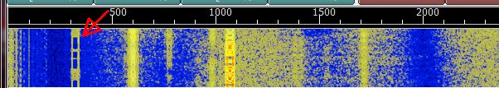
Let’s look at the signal indicated with the red arrow.
First, it is at an offset of ~300 Hz which makes its true frequency 14.0713 MHz. If you know that most casual PSK’ers hang out between 14.070 and 14.072 MHz, you have your first clue that this is probably some kind of PSK signal.
Second, you notice that the width of this signal is around 40 Hz. This tells you that this is most likely a PSK-31 signal.
Third, I can’t convey here what this signal sounds like, but I can say that it has a distinctive warbling sound with a fundamental pitch of about 300 Hz (equal to the offset). Once this sound gets fixed in your mind, you will have no trouble identifying it as a PSK signal.
Finally, it appears like a miniature ladder whose sides keep switching - - sort of a twisting herring-bone look. This is distinctive to a PSK signal.
Put all four clues together and you can bet your bottom dollar that this signal is coming from a casual user (not a county hunter) using a PSK mode (sub mode BPSK-31).

Here is another example (Radio dial set to 14076 MHz):
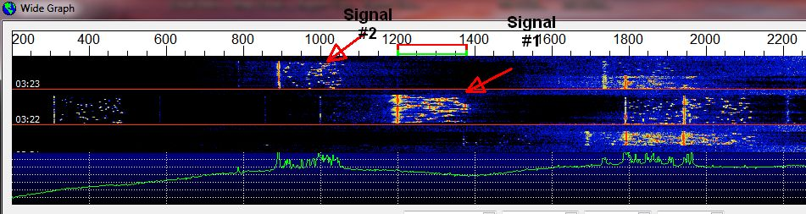
Let’s examine Signal #1.
First, its true frequency is 14.0772 MHz (Dial of 14.076 + 1200 Hz offset). We know that JT65 users typically hang out between 14.076 and 14.078 MHz. This is a pretty good clue that this is a JT65 signal.
Second, it looks to be about 175 Hz wide. This is close to the width of a JT65 signal.
Third, when listening to it, you can hear a base tone at about 1200 Hz with a lot of short tone bursts of several higher frequencies. These correspond to the small horizontal marks to the right of the base tone. Unfortunately, the sound of this signal is similar to what some other modes sound like, so sound is a weak clue.
Fourth, and last, this signal just looks like a JT65 signal! It’s sort of like recognizing an old friend’s face.
Putting all 4 clues together, you can be almost 100% sure that this signal is using the JT65 mode (JT65 mode has NO sub modes)

Here is another example (Radio dial set at 14.074 MHz):
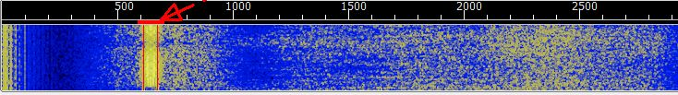
First, the true frequency of this signal is ~ 14.07465 MHz (14.074 MHz + 650 Hz offset). This is higher than the usual frequency range for PSK31 signals and lower than the lowest frequency commonly used by JT65 signals. We also know that digital people commonly use the range of 14.072 MHz to 14.076 MHz for wider modes like MFSK, DOMINO, OLIVIA, CONTESTIA, PSK63, etc. In addition, frequencies around 14.074 MHz or 14.075 MHz are commonly used by county hunter mobiles putting out counties using digital modes.
Second, the width of the signal is close to 80 Hz. This matches the width of a PSK63 signal very well.
Third, like PSK31, PSK63 has a unique sound all its own. Once you have this fixed in your brain, you can easily identify this mode/sub mode in the future.
Fourth, and last, a PSK63 signal looks just like a PSK31 signal only it is twice as wide and twice as fast.
If you combine all 4 clues with the fact that you have been alerted (by a spot) that a mobile is putting a county out using digital modes, you can be pretty sure that this signal is a mobile county hunter using PSK63.

For more detail on the various digital modes, I strongly suggest that you check out the following web site of G4UCJ: http://hfradio.org.uk/html/digital_modes.html . It has great descriptions of many different digital modes. It also has good audio clips of actual transmissions so you can learn what each mode sounds like. Short descriptions of RSID and Video Text are also covered.

Typical Modes Used On Digital Mobile Runs And Why.
This topic is very much a moving target! As more people get involved with running counties mobile using digital modes, each one develops their own preferences and techniques. As time passes, I’m sure that these ideas will merge into a more stable set of standards, but, in my opinion, it is too early for that to happen now. Digital county hunting still needs to consider every new idea that comes down the pike. Besides, dealing with new ideas is half the fun! What follows should be thought of as preliminary and subject to change after more testing is done and county hunters gain more experience.
Terry (WQ7A) and I conducted over-the-air tests of almost every mode and sub mode supported by Fldigi (82 total). We tested for Band Width, Time needed to send a standard length message (which was converted to equivalent Words/Minute speed, and made notes on usability, lags, etc. Based on these tests, I narrowed the list down to 22 candidates which might be suitable for use by county hunters. This list was published in an earlier issue of Digital Happenings.
With a little additional pruning, I have come up with a “Shopping List” of 18 digital modes and sub modes which might be useful for running counties while mobile. Here it is:
You may notice that PSK-31 and MFSK-16 are conspicuous by their absence. Why? It is simply that they are both too slow for efficient use of your time when putting out counties (already a slow process compared to CW or SSB).
On the other hand, even if these two modes are slow, they may still be useful if propagation is poor. Here is a rule of thumb which can help you decide. For the same mode, whenever you double the speed, you lose ~ 3 dB S/N capability and double the band width.
Stated another way, if you double the speed of a mode, you will also need to double your power output to be heard at the other end with the same signal strength.
When Sharon and I are running counties (digital) we mostly use PSK-63, RTTY-45, and MFSK-32 (in that order) when we are only putting out 3 digital modes. If we have time for a fourth mode, we usually use either DOMINO-22 or OLIVIA 8/1000. These are just suggestions and are certainly not “cast in concrete”. For example, some people (who use an Elecraft K-3 without an interface) can only transmit on PSK-31 and RTTY-45! Other digital software may not support some of these modes/sub modes either. Regardless of what modes you end up using, you will be welcomed with open arms as there are a growing number of people now pursuing the new digital awards. The key is to publicize your trip in advance (on K3IMC Planned Trips) and to get yourself spotted on the W6RK spotting site.
The Rest Of The Story:
Well folks, I again ran out of space before I could totally answer the original question. I’ll try to finish answering this question next month by discussing the following topics:
What Is RSID (Reed-Solomon Identification) and Video Text? How Do You Use Them In FLDigi?
Compatibility Issues When Making RTTY Contacts.

February Activities:
Digital activities during February picked up tremendously! Digital county hunter mobiles spotted on W6RK in February and a rough count of each’s total spotted counties/modes are:
W0NAC/N0LXJ > 13
K5YAA 59
KW1DX 35
N4WYR 1
WA4UNS 1
I’m sure the numbers are actually higher since not every mode in a county gets spotted. There would have been even more digital opportunities for you if our trip had not been cut short by the antenna failure.
Special Notice:
The free SignalLink USB put up for grabs last month has found a good home! Both the donor and the recipient will remain anonymous.
The updated Table 3 is given below:
Please note that N6PDB has joined the small group of those who have completed 50% or more of the 5 – Mode Award. Congratulations Dennis!
How To Get Your 5 – Mode Statistics Updated:
Several past Digital Happenings articles have given detailed instructions on a new and easy way to update your digital statistics for Table 3 by using a small program called “Digital Report Utility”. This new program will create a report for you showing your progress for both the USA – Digital and the 5 – Mode Awards and email it to W0NAC. Instead of repeating these instructions every month I have included them in a Microsoft Word document that you can download by clicking on the following link: https://dl.dropboxusercontent.com/u/26171574/Happenings/5%20Mode%20Update.doc

Other possible topics for future months include (in no particular order):
“How To Log Your Digital Contacts In Logger”
“Macros – Revisited”
“New Digital Awards?”
“Digital Software Installation – Revisited”
“Award Difficulty Index”
I hate to keep harping at you all, but I really need (and welcome) your suggestions on topics for future articles! Or, if you have a story or tip that you wish to contribute, I will certainly try to include it. Short stories describing your experiences/joys/frustrations/etc. in getting started in digital ops would be especially welcome. Summaries of any digital trips you make (or have made in the past) would also be good. I look forward to hearing from you. Don’t be shy!
Please email me with your comments/suggestions at w0nac@comcast.net and don’t forget to send your updated status for the USA – Digital and 5 - Mode Awards so I can update the Active Digital County Hunters Award Status list again next month.
73’s and we hope to see you on our waterfall again real soon!
Matt – W0NAC

