DIGITAL HAPPENINGS #18
(January 2014)
By W0NAC (“Matt”)
You may have heard the old rhyme:
Spring has sprung,
Fall has fell,
Winter has come,
And it’s colder than…..usual !!
Bad weather may explain the general lull in county hunting these last few months, but then again, maybe not. There are probably multiple other reasons in addition to cold weather. Sharon and I have to plead guilty to not getting out there and running digital counties even though we wanted to. Our only excuse is that life just seemed to get in the way of county hunting. However, as seasoned county hunters will tell you: “The counties will still be there. They aren’t going anywhere!”.
A special “atta-boy” goes to KW1DX who recently made his first mobile run using digital modes in Cheshire, MA on PSK-31! A combination of snow and his GPS trying to lead him onto a back road caused him to terminate his maiden voyage early, but I’m sure that there will be more when the weather warms up. Thanks, Dave, and know that you are a welcome addition to the growing group of active digital mobiles!
I frequently get asked questions like “How in the *@!X! do I find and work other digital county hunters?”. I have tried to answer this question in earlier articles, but it still seems to be a real puzzlement for many people, so at the risk of repeating myself, I am going to talk about this subject again. Maybe I can do a better job a second time.

How To Find And Work Other Digital Mobiles:
True Frequency – You really need to understand the concept of “True” frequency before you can understand and use practical methods of tuning to find other digital stations and setting your own transmitting frequency while using the various digital modes. Please stay with me while I give you a little of the underlying theory on how digital signals are created.
Let’s start with creating a simple CW signal. You can just key your transmitter ON and OFF using a mechanical/electronic keying device (after tuning your XCVR to the desired frequency). If the person trying to listen to your signal tunes a simple receiver to exactly match your transmit frequency, they will hear NOTHING. To hear your signal with the desired audio tone, they need to offset their receiver frequency by a few hundred Hz. In a typical modern XCVR these offsets are handled in such a way as to be simple and “transparent” to the user and the “True” frequency is usually the same as the dial reading.
A typical Single Sideband Suppressed Carrier (SSB) signal can start with a single carrier signal (much like the CW signal above), but instead of being keyed on and off the carrier is amplitude modulated with audio (voice) from a microphone. This results in an Amplitude Modulated (AM) signal which consists of the original carrier and 2 sidebands which contain all the information you wish to send. If you then suppress the carrier (which serves no useful purpose anyway) and also filter off the lower of the two sidebands, you end up with a signal containing just the upper sideband. This would be an Upper Sideband (USB) signal whose “True” frequency for tuning is the same as the frequency of the missing carrier (Dial Frequency on most XCVRs). With voice modulation, the USB signal can extend higher in frequency by as much as 2.7 KHz above the “True” frequency. This is why you must be very careful to not set your dial higher than about 3 KHz below the upper band limit when operating USB near the high end of a band. For example, if operating USB on the 20M band, the highest you should set your dial is ~14.347 MHz. If you were to set your dial to 14.348 MHz, you might transmit a signal that extends outside legal band limits.
Now, if you take your modern XCVR, set it to the USB mode, set the dial to exactly 14.1000 MHz, and inject an pure audio tone of 500 Hz into the microphone jack (with the transmitter keyed ON), your XCVR will generate a single CW carrier signal at 14.1005 KHz.
You can then key the 500Hz audio tone ON and OFF with a keyer and obtain the same result as if you keyed the carrier directly. Provided certain conditions are met, both the mechanically produced CW signal and the software generated CW signal are almost exactly the same (Emission type A1A). In fact, some modern XCVR manufacturers use software techniques to generate their CW signals instead of directly keying the amplifier.
All modes used in amateur radio have a finite bandwidth. This begs the question of what is the “True” frequency for each mode. Do you use the left (lowest) side of the signal, the right (upper) side of the signal, or the center? Any of the three options is correct, but a choice must be made to avoid confusion. The problem is resolved by agreeing to a standard convention (similar to the one that when operating SSB USB is used on 20M and up and LSB is used on 40M and lower).
For county hunting I suggest that we agree to the conventions given in the table below with ALL digital modes operated with the XCVR set to USB (even for 40M and lower). With the exception of RTTY (most commonly operated by non-county hunters with the radio set to LSB), these conventions match up well with the rest of the digital operators. I will discuss the RTTY compatibility issue at length next month. In the interim, all county hunter to county hunter RTTY contacts should work just fine. If you have difficulty decoding the RTTY signals of non-county hunters, try clicking on the “Rv” (Reverse) button near the bottom right of your FLDigi screen. This will reverse the “polarity” of your RTTY signal.

Why is all this important? The reason is that to avoid confusion and have everyone playing by the same rules, all spots should be entered using “True” frequencies. Then, knowing how “True” frequency is specified for that mode, you can set your XCVR dial to a setting that will allow you to find the signal that was spotted. Let me give you a few examples.
Example #1 - You have been monitoring one of the 4 spotting sites available in Logger (K5UGD, W6RK, K4PBX, W0MU). You receive an audio alert for a new spot where the mobile team of W0NAC/N0LXJ is putting out Custer county, CO on PSK31 on a frequency of 14.074 MHz (If the spotter is following standard practice, this is their “True” frequency). You wish to see their signal in the “sweet spot” for most sound cards (between ~500 Hz and ~1500 Hz). Knowing that “True” frequency on your waterfall is your XCVR dial setting plus the offset on the waterfall, you determine that you need to set your XCVR dial to 14.073 MHz. With this dial setting, the signal should appear around the 1000 Hz plus offset point on your waterfall display.
Example #2 - Let’s say that Lloyd (NX4W) wants to put out the county line of Bacon/Pierce, GA. He wants to transmit on a “True” frequency of 14.073 MHz using PSK-63. Since he knows that “True” frequency is his XCVR dial setting plus the offset on his waterfall, he will set his XCVR dial to 14.072 MHz and then click on his waterfall near the 1000 Hz offset point on the scale. This will put his “True” operating frequency at 14.073 MHz which he will announce in his spot (if he is spotting himself) or be specified as 14.073 MHz by whoever is spotting him.
Example #3 – A new spot is displayed showing that N5MLP is running the county of Deaf Smith, TX using RTTY-45 on a “True” Frequency of 18.100 MHz in the 17M Band. To receive (and transmit) on his “True” frequency, you would set your XCVR to USB Mode and set the dial to 18.099 MHz. Then on your waterfall you would look around the 1000 Hz offset point for his signal. I say “around” because most county hunters putting out digital counties will need to adjust their transmit frequency up or down a bit to avoid QRMing other signals. If there are multiple signals near the announced frequency, you can usually tell which one is the one you want by the content (county hunter digital runs use short transmissions and a fixed format).
Since JT65-HF, JT65, and JT9-1 modes are never used for mobile digital runs (TOO Slow!), they are not typically spotted. In this case, the only reason you need to be aware of “True” frequency is when you might be operating close to a band edge or for super accurate logging. For all 3 modes, the “True” frequency convention is to use the leftmost edge of the signal trace. So, if you are operating with your XCVR set to USB the highest frequency component of your signal will be ~ 175 Hz higher than the “True” frequency for JT65 and ~16 Hz higher than the “True” frequency for JT9-1.
The Offset scale when using JT65-HF software is a unique case. It displays a scale with “0” at the middle of the offset scale (nominal center of the audio pass-band) with negative numbers to the left and positive numbers to the right. “0” on the JT65-HF offset scale actually represents a true offset of 1270.5 Hz. All other digital software programs I am aware of including FLDigi and WSJT-X software display their offset scale with “0” at the far left end of the audio pass-band (0 Hz). Examples of all three are shown below:
JT65-HF Spectrum Waterfall Display
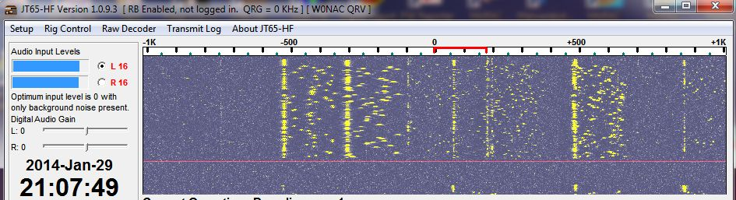
JT65 (WSJT-X) Spectrum Waterfall Display
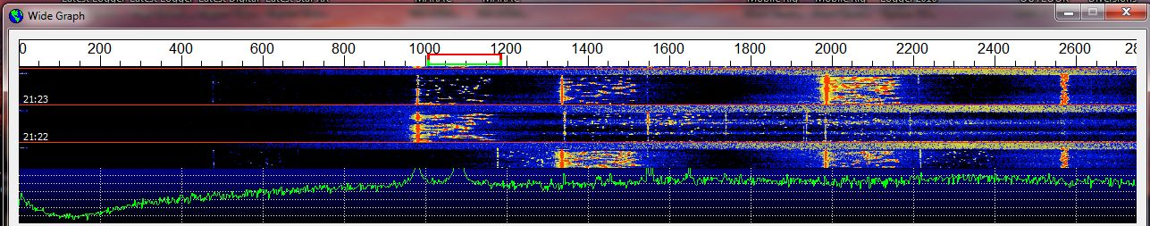
JT9-1 (WSJT-X) Spectrum Waterfall Display
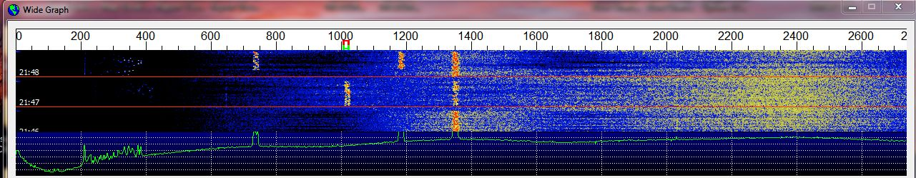
Here is how you can determine the lower and upper frequency limits of your signal for each mode.
Note: For the JT65-HF case the left end of the red signal bracket is aligned with the “0” point on the
offset scale (which is an actual offset of 1270.5 Hz). For the JT65 (WSJT-X) and
JT9-1 (WSJT-X) cases the left end of the red signal bracket is aligned with the
“1000” point on the offset scale (which is an actual offset of 1000 Hz).
When using JT65-HF software, the “True” frequency (also the lowest frequency component of your signal) is your dial setting (14.076 MHz) plus the actual offset (1270.5 Hz) = 14.0772705 MHz. The highest frequency component of your signal is just 175 Hz (signal band-width) up from the lower frequency or 14.0774455 MHz.
Using JT65 (WSJT-X) software, the “True” frequency (also the lowest frequency component of your signal) is your dial setting (still 14.076 MHz) plus the offset (1000 Hz) = 14.077000 MHz. The highest frequency component of your signal is still 175 Hz (signal band-width) up from the lower frequency or 14.077175 MHz.
Using JT9-1 (WSJT-X) software, the “True” frequency (also the lowest frequency component of your signal) is your dial setting (now 14.078 MHz) plus the offset (1000 Hz) = 14.079000 MHz. The highest frequency component of your signal is now 16 Hz (signal band-width) up from the lower frequency or 14.079016 MHz.
Typical Digital Frequencies Used By County Hunters:
Given below is a suggested band plan for digital county hunters (operating mobile). It is certainly “not cast in concrete”, but seems to work out well in practice. Also, the frequencies suggested are given as XCVR dial settings (what you see on your radio dial). When your dial is set as suggested and an offset of ~1000 Hz is selected on your waterfall, the “True” frequency will be 1 KHz higher than the dial setting. “True” frequency is what should be announced in any spots.
Mobile Suggested Band Plan For Digital Operation
These frequencies have been carefully selected so that they don’t conflict with other digital operations. For example, on the 20M band, “rag chew” and other casual PSK-31 and PSK-63 QSOs typically occur on “True” frequencies between 14.070 MHz and 14.073 MHz. Wider digital signals (such as RTTY, Contestia, etc.) are not welcome in this segment of the band. JT65 contacts are traditionally made on frequencies between 14.076 MHz and 14.078 MHz. JT9 contacts are typically made on frequencies 2 KHz higher than JT65 (14.078 MHz to 14.080 MHz). This leaves a 3 KHz slice of frequencies between 14.073 MHz and 14.076 MHz available for county hunter use. For these reasons, I recommend that county hunters use “True” frequencies of either 14.074 MHz or 14.075 MHz (dial setting of either 14.073 MHz or 14.074 MHz.

The Rest Of The Story:
Well folks, I ran out of space before I could totally answer the original question. I will try to finish answering this question next month by discussing the following topics:
How Do I Tell What Mode The Other Guy Is Using?
Typical Modes Used On Digital Mobile Runs And Why.
What Is RSID (Reed-Solomon Identification) And Video Text? How Do You Use Them In FLDigi?
Compatibility Issues When Making RTTY Contacts.

January Activities:
Digital activities during January picked up, but remain low. Digital stations spotted on W6RK were:
01/01 K8GI/4 Glynn, GA RTTY-45
01/01 W1AW/4 Iredell, NC RTTY-45
01/09 W0NAC/N0LXJ Douglas, CO PSK-31
01/19 KW1DX Cheshire, NH PSK-31
01/22 AG7LB Oneida, ID PSK-31
01/27 KA4RRU Culpeper/Rappahannock, VA PSK-31
There were undoubtedly many other digital stations out there, but they were not county hunters and were not spotted on W6RK.
Special Notice:
If there is someone out there who would really like to get going on digital operations (Fixed or Mobile), but can’t afford to buy the equipment needed, I have an almost brand new SignaLink USB interface, cable, and manual available for free (a $100.00 value). Please be aware that the cable may not be the correct one for your transceiver. You may have to purchase a different cable ($20.00). This equipment was sent to me by a donor who wishes to stay anonymous. All you need to do is send an email to me at w0nac@comcast.net stating how this unit will help you. Near the end of February I will select the one I judge to need it the most and will send it to them postpaid. If more than one person makes a good case, then a random drawing will be used to decide who gets it. The winner will remain anonymous, but I will make note in my article when the equipment has found a new home.
The updated Table 3 is given below:
How To Get Your 5 – Mode Statistics Updated:
Several past Digital Happenings articles have given detailed instructions on a new and easy way to update your digital statistics for Table 3 by using a small program called “Digital Report Utility”. This new program will create a report for you showing your progress for both the USA – Digital and the 5 – Mode Awards and email it to W0NAC. Instead of repeating these instructions every month I have included them in a Microsoft Word document that you can download by clicking on the following link: https://dl.dropboxusercontent.com/u/26171574/Happenings/5%20Mode%20Update.doc

Other possible topics for the coming months include (in no particular order):
“How To Log Your Digital Contacts In Logger”
“Macros – Revisited”
“New Digital Awards?”
“Digital Software Installation – Revisited”
“Award Difficulty Index”
Come on Guys and Gals! I still really need (and welcome) your suggestions on topics for future articles! Or, if you have a story or tip that you wish to contribute, I will certainly try to include it. Short stories describing your experiences/joys/frustrations/etc. in getting started in digital ops would be especially welcome. Summaries of any digital trips you make (or have made in the past) would also be good. I look forward to hearing from you. Don’t be shy!
Please email me with your comments/suggestions at w0nac@comcast.net and don’t forget to send your updated status for the USA – Digital and 5 - Mode Awards so I can update the Active Digital County Hunters Award Status list again next month.
73’s and we hope to see you on our waterfall again real soon!
Matt – W0NAC

