DIGITAL HAPPENINGS #16
(November 2013)
By W0NAC (“Matt”)

Because of the holiday season and other things I need to do, this month’s article will be a bit shorter than past articles. (Maybe you are saying “That’s a good thing!”) However, I will follow through this month on describing the rest of my experiences installing our rig in the new Volkswagen Passat TDI Diesel. It is still my hope that having a better understanding of the process will encourage some of you to go ahead and install (and operate!) a digital mobile station. Also, for the time being, there will be no new puzzles issued. Starting next month the Challenge Department will go away.

Challenge Department:
Last month I challenged you to solve the following puzzle:
“Crossing a Rickety Bridge at Night by Flashlight”
A group of four people (Annie, Bob, Carl, and Deral) need to cross a bridge. It is dark and they must light their path with a flashlight. No more than two people can cross the bridge simultaneously, and the entire group has only one flashlight. Different people take different times to cross the bridge and the slowest person in any group determines the time to cross.
Annie can cross the bridge in 1 minute
Bob can cross the bridge in 2 minutes
Carl takes 5 minutes to cross the bridge
Deral is the slow poke! It takes him 10 minutes to cross the bridge
How can the entire group make it to the other side of the bridge in 17 minutes maximum?
Two people submitted solutions this month (in the order given below).
1 - KB9VQM – Louie (Correct with 17 minutes total)
2 - W2CC – Dave (Correct with 17 minutes total)
There are 2 correct solutions for this puzzle as follows:
Solution A
Step Action Minutes Required Total Elapsed Time
0 (Start) 0 0
1 Annie & Bob Cross Together 2 2
2 Bob Returns 2 4
3 Carl & Deral Cross Together 10 14
4 Annie Returns 1 15
5 Annie & Bob Cross Together 2 17 (All are now on the other side)

Solution B
Step Action Minutes Required Total Elapsed Time
0 (Start) 0 0
1 Annie & Bob Cross Together 2 2
2 Annie Returns 1 3
3 Carl & Deral Cross Together 10 13
4 Bob Returns 2 15
5 Annie & Bob Cross Together 2 17 (All are now on the other side)
You will note that the only differences between these solutions are in steps 2 and 4.

STORY OF W0NAC’S NEW MOBILE INSTALLATION (CONTINUED)
Please let me reiterate that this is not intended to be a complete “How To” book on mobile installation. I will only be hitting high points. Also, this story contains a lot of personal opinion based on many years of experience.
Last month, I covered the following topics at some length:
1) PICKING THE VEHICLE
2) INSTALLATION SO FAR
Now for the rest of the story:
3) INSTALLATION CONTINUED
When the trailer hitch came in, I had the dealer install it. Since I was planning to use it primarily as an antenna mount, I insisted that they install it with stainless steel hardware and special serrated washers that would “bite” through any paint on the hitch.
I purchased a new receiver extension with several inches rise plus a simple extension so that the trunk lid will clear the antenna as it opens. The ball mounting hole had to be enlarged to 1.0 inches to accommodate the remaining parts of my mount. The extensions were then secured by heavy duty stainless bolts. Since the extension parts are coated with paint (an insulator), they would not make good electrical connections to the grounded hitch, so I added 2 heavy duty cables between the antenna mount and the trailer hitch mounting bolts which effectively bypassed the open circuits between the extension parts. Tip: It is essential that you have a “good” ground connection between your antenna base and the car’s body because the entire car is the other half of your antenna! You can see the details of this arrangement on our car in the photos below.

Trailer Hitch Grounding Bottom Of Antenna Mount
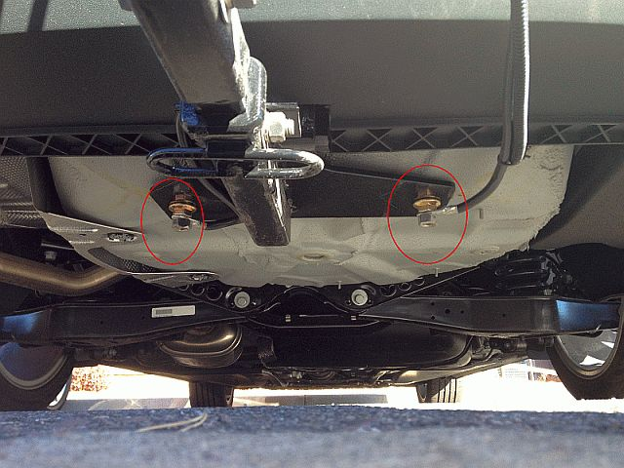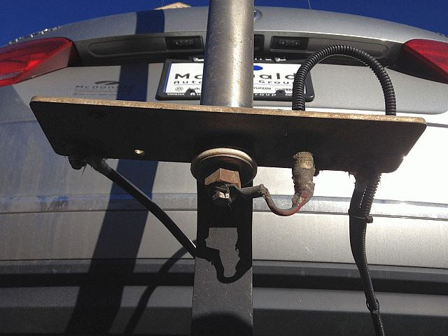

I then installed the rest of the antenna (which must be insulated from the base) through the 1.0 inch hole in the receiver extension using a special plastic insulator that was “printed” by a friend using his new 3D Printer. The antenna is still the same hybrid design with standard linear resonators at the top o the mast for the 80M, 40M, 30M, and 20M bands. “Flying Saucer” resonators (design by W9UCW) are spaced down the mast for 17M, 15M, 12M, and 10M. It is guyed using mono-filament line attached to heavy duty metal cup holders glued to the rear window of the car.

Top Of Antenna Mount (Looking Down) Upper Antenna With Resonators (Looking Up)
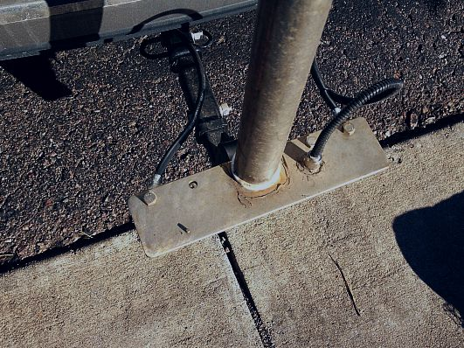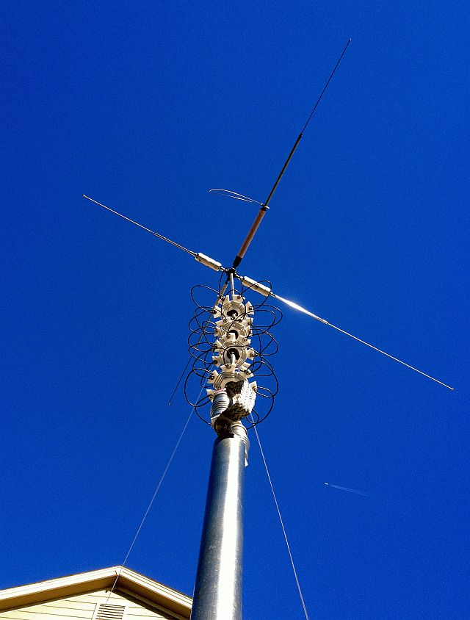
After I finished installing the antenna, I took the car to Car Toys to complete the wiring. This turned out to be a rather “monumental” job that took 3 days and cost over $1000 in labor. Even though it was expensive, I am very pleased with the result. At my age (81) I am no longer physically able to do what was needed and don’t have the special tools required to remove and re-install body panels or the skills to safely work around air bags.
I gave the installer a hand drawn sketch which showed how each item of equipment interconnected. By following this sketch plus occasional “hands on” instruction, the installer was able to complete the job with a minimum number of problems. Recently, I have converted this sketch into a vector graphics chart by using a free software program called “Draw Plus” by Serif. This is a great piece of software and if you need software to create professional looking charts, I highly recommend it. Here is the final result:
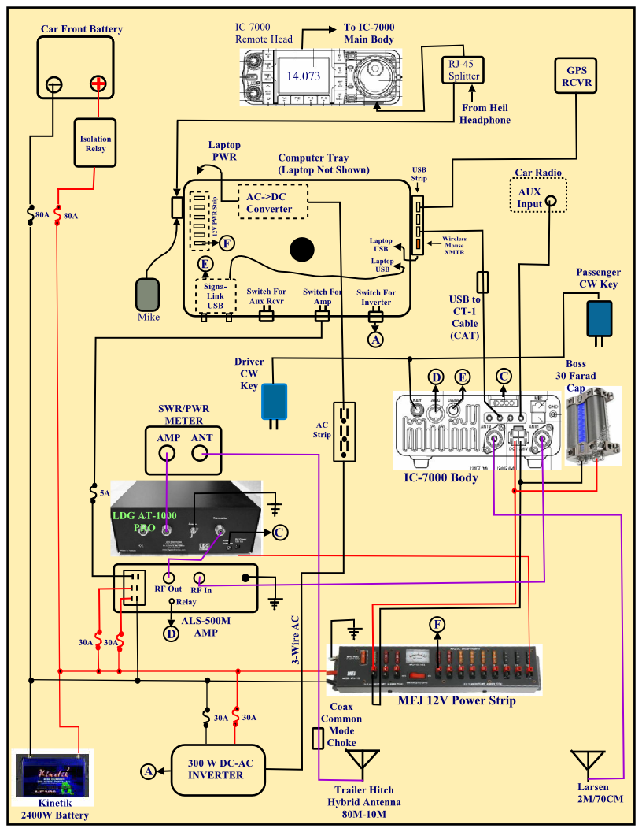
When looking at this chart, there are several things you should note:
1) This chart shows very roughly where the various items of equipment are physically located in the car.
2) Some wiring (particularly underneath the laptop tray) is not shown.
3) Some items of equipment (Heil headset/mike, auxilliary transceiver, radar detector) and their connections are not shown.
4) Every individual wire and every pin is not shown.
5) Some of the connections are individual wires and others are multi-wire cables or coax.
6) Connector pins are not necessarily shown exactly as they really are, but stylistically.
All of this was done to simplify the chart. It would have been overly complex and impossible to depict on a single drawing otherwise.
4) INSTALLATION PROBLEMS
Overall, the installer did a great job! However, he did make 2 errors – one rather minor, and the other serious. He managed to get the wires crossed on Sharon’s CW key so that dots and dashes were reversed on her paddle. This I managed to fix rather easily with a splice in the cable.
The serious problem was that when he went looking for a powered lead to tap into for the radar detector, he apparently tapped into a critical computer lead which totally killed the keyless start system. When I arrived to take delivery of the car, I discovered that there was absolutely no way to start the engine and had to leave it with Car Toys for another day. After much effort (unpaid of course), he finally discovered the root of the problem and connected the radar detector to another source of power and all was well.
4) HOW DOES IT WORK?
In a word – ABSOLUTELY GREAT!
The car itself and all installed equipment are totally quiet. No random noise, no hash, no “birdies”, no ignition noise, no alternator whine, NOTHING! Naturally, Mother Nature still generates her share of RF background noise, but with DSP filters, etc. this can be minimized. We can now copy “22” signals while moving down the road and no longer need to pull over and shut the engine off to take relays. Hooray!
Most people are not aware of other EMC problems where, especially when using high power, your own RF signal is so strong that it can disrupt proper functioning of the car’s computer(s) causing engine lights to come on or even cause the engine to lose power or stall out! I have experienced all of these problems at various times in the past. Also, the car computer’s sensitivity to your own signal can’t be tested in advance. You must wait until after your installation is complete to find out if you have an EMC problem. Fortunately, the Passat operates without a glitch with the linear putting out over 300 watts on all bands (200W max on 30M). Tip: To help avoid EMC problems in your car, feed your mobile antenna with a longer piece of coax than needed so that you can coil up several turns of coax near the antenna feed point and clamp on 2 or more large ferrite beads (enclosing all turns) to create a common mode filter. This will help keep RF from flowing on the outside of the coax.
Mechanically, the Passat is much quieter than most of the other cars I have had and it also rides better. In addition, feeding audio from the IC-7000 directly into the car’s audio system “AUX” input works nicely and yields great sound. The only glitch is that the Passat with keyless ignition has no accessory position to run the radio and sound system when the engine is stopped. The radio and audio system can be activated with the ignition off, but you have to do this manually by turning the radio power switch ON. Unfortunately, after about 30 minutes, the radio automatically turns itself OFF. This could happen in the middle of a long run if sitting on a county line. Fortunately, you can immediately turn it back on and start another 30 minute timeout cycle, but you will lose all audio for a few seconds, perhaps at a critical time.
FINAL COMMENTS ON THIS INSTALLATION
Admittedly, the rig setup described here is complex and contains a lot more equipment than is really needed for digital county hunting. For example, the linear amplifier is definitely “over-kill” for digital operations. If you only wish to operate on 30 Meters or higher in frequency, the tuner can probably be eliminated. For strictly digital ops, no CW keys are needed. Also, the 12V power distribution can be greatly simplified by eliminating the extra battery.
The only truly essential items are a laptop computer (with digital software), a transceiver (with antennas for the bands you wish to operate on), and an interface unit. All the other equipment was added for a variety of reasons such as expanded band coverage using all modes, better signal on SSB and CW, simplified band changing, or just plain operator convenience. Please don’t let the complexity of this setup scare you away from even trying to put together a digital rig of your own. Also, if you already operate a mobile rig on SSB or CW, the only additional equipment you need to go digital is a laptop computer (with software) and an interface box.
FUTURE TRIP PLANS
Sharon and I will soon be going on our “maiden voyage” with the new Passat and rig. We are thinking about a 3 day trip putting out (digital of course) counties in the panhandle of Texas and/or counties in southern Oklahoma. This trip may happen in late December if Sharon recovers soon enough from carpel tunnel surgery on December 4th. I will publicize our detailed plan as far in advance as I can both by direct email and in “Planned Trips” on the K3IMC web site.

November Activities:
Digital activities during November were even lower than in October. The only digital stations spotted on W6RK were:
11/12 W0NAC Douglas, CO PSK-63, RTTY-45
11/17 W0NAC Arapahoe, CO PSK-63, RTTY-45, DOMINO-22
11/25 KH6/G4KHG Kauai, HI Spotted on 14.070 – PSK-31??
There were probably other digital stations out there (maybe working state QSO parties or other contests?), but they were not spotted on W6RK.
There were several support calls related to digital setup, etc. in November. Maybe this article will inspire some new people to call. If you would like some help getting started with digital operations, just email me at w0nac@comcast.net or call me any time at 303-799-3658. If you need someone to make test digital contacts with, I am also willing and able to do that.
The updated Table 3 is given below:
As you can see, the table is gradually filling up with more people reporting their status.
How To Get Your 5 – Mode Statistics Updated:
In the past two Digital Happenings articles I have given detailed instructions on a new and easy way to update your digital statistics for Table 3 by using a small program called “Digital Report Utility”. This new program will create a report for you showing your progress for both the USA – Digital and the 5 – Mode Awards. Here is a sample screen shot of a typical report using N0KV’s (Barry’s) database:
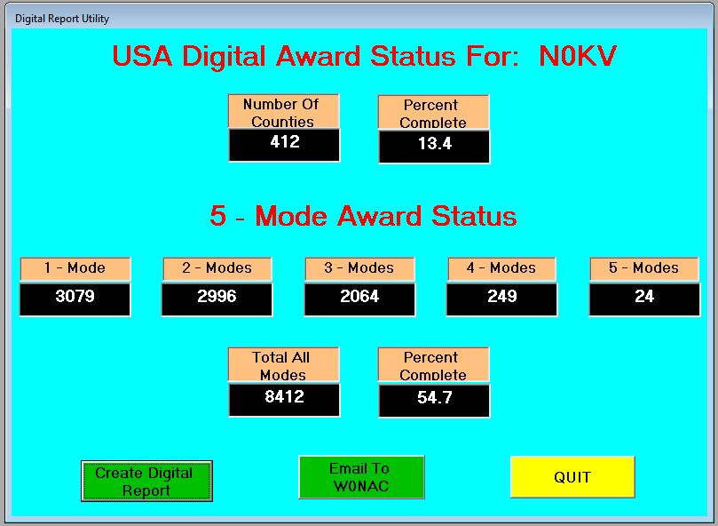
Once your own report is showing on your screen and you are OK with the numbers, the program can also email your statistics to me so I can update Table 3. There is no longer a need for anyone to manually extract their statistics.
If you would like to use this new utility, download the file “Install Digital Report Utility Version 0.1.9.exe” from the MARAC Server ( http://www.marac.org/chdownloads ). You may save this file anywhere you wish on your computer (desktop, download folder, etc.) because it is not sensitive to location. Running this file will install the new utility program in the proper folder (Program Files or Program Files (x86)) and place an icon on your desktop that you can use to run it. Once the new program has been installed, you can delete the install file if you wish.
Please Note: When you first run the new program you need to make sure that it points to your call sign database file (files if you are an OM/YL team). This file(s) will usually be found in your “C:\Logger Data” folder.
To point the program to your file(s), press F-10 while on the opening screen. Please see past articles for more detailed instructions if you need them.

Since it is nice and easy now, I encourage everyone listed on the table to use the new utility to email me current statistics NLT December 27th so I can update the table with your information. If there is anyone not listed inTable 3 who would like their statistics included, just run the utility and have it email your numbers to me. I will get you listed!
Caution: The email portion of this program may not work with every email client out there, especially web based email clients. If that part doesn’t work for you, just include your numbers in an email that you create manually using your own email client and send it to w0nac@comcast.net . Many Thanks!
Possible topics for the coming months include (in no particular order):
“New JT65 and JT9 Software”
“How To Log Your Digital Contacts In Logger”
“Macros – Revisited”
“New Digital Awards?”
“Digital Software Installation – Revisited”
“Award Difficulty Index”
As always, I still need (and welcome) your suggestions on topics for future articles! Or if you have something you wish to contribute I will certainly try to include it. Short stories describing your experiences/frustrations/etc. in getting started in digital ops would be especially welcome. Summaries of your digital trips would also be good. I look forward to hearing from you.
Please email me with your comments/suggestions at w0nac@comcast.net and don’t forget to send me your updated status for the USA – Digital and 5 - Mode Awards so I can update the Active Digital County Hunters Award Status list again next month.
73’s and we hope to see you on our waterfall again real soon!
Matt – W0NAC

