DIGITAL HAPPENINGS #14
(September 2013)
By W0NAC (“Matt”)

Usually, this is the place where I attempt to instill in other people the same passion that I have for digital operation. This month I just couldn’t seem to find a new way to do this (I can hear your sigh of relief all the way here in Colorado!). So, just to be different, I decided to engage you in a brief exchange regarding your motives for being a County Hunter and some of the words we might use to describe these motives.
I and many others have used the words “fun”, “happiness”, and “joy” when we talk about our ham radio activities. I have to admit that in the past, I have used “happiness” and “joy” almost interchangably. The following are dictionary definitions for each of these words:
“fun” – (noun) – enjoyment, amusement, or lighthearted pleasure.
“happiness” – (noun) – the state of being happy (synonyms: pleasure, contentment, satisfaction).
“joy” – (noun) – a feeling of great pleasure and happiness.
In a biblical sense, “joy” is a deep and permanent state of well being where one is right with God. Contrast this with “happiness” which is a feeling that can be very fleeting and temporary.
As Rush Limbaugh is fond of saying: “Words mean things.” What do these three words mean to you? Which of these words (or perhaps some other word) would you use to best describe what you get from ham radio and county hunting?
After you answer this question for yourself, I would like it if you would email a short sentence or two with your answer to this question and your reason(s) for answering it that way. I will quote all replies in next month’s article (with permission, of course). Should be “fun”!!
Challenge Department:
Last month I challenged you to solve a different kind of puzzle sent in by Kirby (W8DCD) as follows:
You have 2 rooms. In room 1, there are 3 light switches that go to 3 lights in room 2. There is a door that separates the rooms so you cannot see between them. You are in room 1 with no tools or any other help. You need to arrange the light switches then go into room 2 and tell me which switch goes to which light. You can only pass through the door once and cannot see between. This is NOT a trick answer….just requires a little bit of logic and common sense. What can you do in room 1 to tell you what’s up in room 2?
The solution I came up with was to:
1) Make sure all three switches are OFF and have been OFF for at least 15 or 20 minutes.
2) Turn switch #1 ON for several minutes.
3) Turn switch #1 OFF and Turn switch #2 ON and quickly move into Room 2.
4) The light in Room 2 that is illuminated is connected to switch #2.
5) The light in Room 2 that is OFF, but still Warm to the touch is connected to switch #1.
6) The light in Room 2 that is OFF and cool to the touch is connected to switch #3.
Sharon came up with a different solution. Her solution assumes that all three lights in Room 2 take a minute or so to reach full brightness after being turned ON (We have such a light in our bedroom ceiling fixture!). She proposes these steps:
1) Make sure all three switches are OFF and have been OFF for several minutes.
2) Turn switch #1 back ON for several minutes.
3) Turn switch #2 ON and quickly move into Room 2.
4) The light in Room 2 that is fully illuminated is connected to switch #1.
5) The light in Room 2 that is only dimly illuminated, but getting brighter, is connected to switch #2
6) The light in Room 2 that is totally dark (OFF) is connected to switch #3.
Two people submitted good solutions this month (in the order given below). Both of their solutions were very similar to mine.
1 - W2CC - Dave
2 - W9WOC – Frank
I find myself wondering why the low participation. Was it because few found the puzzle interesting, or was it too challenging? If any of you would like to express your opinion, I will welcome an email from you. In any event, many thanks to Kirby for suggesting it.

Here is this month’s puzzle. Have fun with it. I challenge you to solve it without use of the internet!
If you had an infinite supply of water and a 5 quart and a 3 quart pail, how would you measure exactly 4 quarts? And what is the least number of steps you need?
Watch for the solution in next month’s article along with a list of those that sent in their solution(s) to this puzzle. Send your solutions to w0nac@comcast.net .
Choosing Your Digital Software:
Let me state right up front that there are a “ton” of digital software packages available on the internet that you can choose from. I will first give you a few criteria that you can use to help make your choice. I will also give you a table that compares the various software programs.
Listed below are some of the criteria I recommend that you use in making your comparisons (in no particular order). You will need to assign your own relative importance to each criterion. Although you could apply “Decision Analysis” and Bayesian mathematics to this problem, you don’t have to get anywhere near this formal! Let your brain store a simple weighted comparison of the candidates and the right answer (for you) will just “pop” out at the right time – guaranteed!
a) Cost
b) Compatibility with your operating system
b) Number of Modes/Sub-Modes Covered
c) Ease of Use
d) User Support
e) Macro Functions
f) Performance
My experience tells me that there is no single software package that will do everything that you need done. I believe that most people will end up with one main program augmented with several other specialized packages. In my case I ended up using FLDigi as my main digital program with JT65-HFand JT9 software to cover these new modes not supported in FLDigi. I also use MP40 occasionally to “beef up” my tin ear on CW.
The table is given below. Please understand that this table does NOT include all the software available out there. Also, I have purposely excluded software that only works on Linux, Macs, smart phones, etc. Plus, I freely admit to bias being present in some of my comments. What all this means is that you should only use this list as a first filter to narrow your choices down to a smaller number. Ultimately, you will need to install those software packages that you wish to explore further on your own computer and test them to see if they install and run OK and how they work for you and your needs. To help you further, each software package name (Column 1) is also a link that will take you to a download site or the main site for that software. Here is the table:
 | COUNTY HUNTER DIGITAL SOUND CARD SOFTWARE
PROGRAM | LATEST VERSION | MODES SUPPORTED | COST | REMARKS
AALog | V 3.2 | PSK-31, CW, RTTY, Voice | Shareware | Basically a logging program. Integrates with other s/w for xmit/receive
AAVoice | v 1.4.6 | Digital Voice | Shareware | Digital Voice Processor. Uses prepared wav-files for transmission.
ChromaPIX | v 1.6.17 | SSTV | $120.00 | Looks like a nice program, but will not run correctly in Windows 7 (even in XP Compatibility mode). Not recommended.
CW Skimmer | v 1.8 | CW (Decoder Only) | $75.00 | Controversial, yet very interesting multi-channel CW decoder and analyzer. Can decode up to 700 signals in parallel on a 3-GHz P4 if a wideband receiver is used. The CW decoder is very robust and highly sensitive. Not sure at this point what use it will be to County Hunters.
CWGet | v 2.26 | CW (Decoder Only) | Shareware | Integrates with AALog
CWType | v 2.10 | Terminal program for CW Xmit | Freeware | Integrates with AALog
Digipan | v 2.0 | PSK-31 (BPSK/QPSK), FSK31, PSK-63 | Freeware | Old standby! Multiple channel reception. Limited Modes
Fldigi | v 3.21.76 | CW, Contestia, DominoEX, Feld-Hell, MFSK, PSK, Olivia, RTTY, Throb, Thor & Many Others | Freeware | Super piece of software! Support available on Yahoo users group. Highly recommended! Supports more Modes and Sub-Modes than any other program available.
Ham Radio Deluxe | v 6.1.04 | CW, Contestia, DominoEX, Hell, MFSK, MT63, PSK, Olivia, RTTY, Throb, & Thor Plus many sub-modes of each. | $99.95 | Basically a full featured radio control program (CAT) with an integrated digital software package (DM780). This program has every feature but the 'kitchen sink' included, but I find that the user interface is complex and difficult to learn. It also lacks support for some of the faster sub-modes useful to county hunters.
HamScope | v 1.56 | CW, MFSK-16, PACKET, RTTY, PSK-31. | Freeware | Older program with very limited Mode capabilities. Made for Windows versions earlier than XP. No support for XP or later versions of Windows. Not recommended.
Hellschreiber | ?? | Various Hell Modes Only | Freeware | Stand-alone program for Hell only. Since FLDigi, MixW, and Ham Radio Deluxe all have Hell modes, this software is probably not needed.
JT65-HF | v 1.0.93 | Special program to operate JT65 on HF frequencies. Adapted from JT65-A. | Freeware | Excellent mode to use while “trolling” for new counties, but too slow for digital mobile use putting out counties. Great software! Requires extremely accurate computer clock.
JVComm32 | v 2.01 | SSTV | $88.93 | Receives weather charts, NAVTEX, SYNOP, FAX, and SSTV, but only transmits SSTV. Free demo version is available.
MIXW | v 3.1.1 | AMTOR, CONTESTIA, CW, FAX (Rec Only), FSK, HELL, MT63, OLIVIA, PACKET, PACTOR, PSK, RTTY, and SSTV (Rec Only). | $70.00 | Excellent program with good logging capability, but has several short-comings for County Hunters, i.e. No THOR or DOMINOEX Modes. Limited Sub-Mode selections. Very awkward sub-mode selection (few macro commands). Complex/hard to learn macro system. Free demo program available.
MMSSTV | v 1.13A | SSTV Only | Freeware | Slow Scan TV with Windows and Soundcard. Compatible with WinXP - VISTA - Win7. Been around over 10 Years. Nice program!
MMTTY | v 1.68A | RTTY Only | Freeware | RTTY with Windows and Soundcard. Compatible with WinXP - VISTA - Win7
MMVARI | v 0.45 | RTTY, PSK, FSK, and MFSK | Freeware | Multi-Mode with Windows and Soundcard. Compatible with WinXP - VISTA - Win7. Interesting little program, but very limited compared to FLDigi, MixW, or HRD.
MRP 40 | v 4064 | CW Only | $67.46 | If you need software to help decode CW or to transmit CW using your keyboard, this is an excellent choice. MixW and FLDigi also have good CW decoders. None of them will perform miracles!
MultiPSK | v 4.21 | Extremely Wide Selection Of Modes & Sub-Modes | Freeware | Seems to work in Windows 7, but the user I/O interface is one of the worst I have ever seen! After struggling with it for some time, I finally gave it up as unusable. You can try it if you like, but I don't recommend the program for anyone!
MT63 Terminal | v 2.0 | MT63 Only | Freeware | I have had difficulty operating MT63 in FLDigi. If you are interested in running this mode, this free program may be your answer…
SSTV32 | v 1.9.3.80 | SSTV Only | Shareware | Another SSTV Program made for Windows XP or earlier. Seems to work on Windows 7. Not updated for 9 years. There are probably better choices.
TrueTTY | v2.90 | RTTY, PSK-31, PSK-63, MFSK-16 and a few others | Shareware | Integrates with AALog
W1SQLpsk | v 5.0 | PSK-31 (20 Channels) | Freeware | Not updated since 3/19/2002. Will not install on Windows 7 computer.
W95SSTV | v 1.10.290 | SSTV | Shareware | Last updated 19 June 1998. May load outdated DLL files during installation. Not recommended!
WinPSK | v 2.13 | PSK-31 and PSK-63 Only | Freeware | Last updated 6/05/03. Program will run on Windows 7 machine, but won't let you select USB soundcard. Not recommended!
WinWarbler | v 7.7.6 | PSK-31, PSK-63, PSK-125 & RTTY | Freeware | Last updated 9/22/2013. Installs and runs on Windows 7 computer just fine. Very limited in Modes & Sub-Modes supported. Good starter piece of software, but NOT suitable for County Hunting (especially mobile).
WriteLog for Windows | v 11 | Primarily Contest Logging Software | $30.00 | Although provides some support for CW, PSK, and RTTY, it doesn't appear to be useful for County Hunting (especially mobile digital).
WSJT-X | v 0.9 R3166 | JT9-1, JT9-2, JT9-5, JT9-10, JT9-30 | Freeware | Only software which supports new JT9 modes just approved by MARAC BOD. Although too slow for mobile use (putting out counties), JT9 is an excellent weak signal mode to use when 'trolling' for new counties or DX. Requires extremely accurate computer clock.
WSJT | v 7.07 | FSK441, JT6M, JT65, WSPR | Freeware | Only JT6M and JT65 modes are approved by MARAC. Don't confuse JT65 with JT65-HF which is optimized for use on HF frequencies. WSPR is a monitor only mode. 2-Way contacts cannot be made using WSPR.

September Activities:
Digital activities during September were again kinda “slim pickins”. Stations (Mostly mobiles) heard putting out Digital counties were:
9/1 W4BK Sumner, TN RTTY
9/2 W0NAC/N0LXJ Adams/Jefferson, CO PSK-63, RTTY-45, DOMINO-22
9/2 W0NAC/N0LXJ Boulder/Broomfield, CO PSK-63, RTTY-45, DOMINO-22
9/10 W7/G4KHG Navaho, AZ PSK-31
9/12 WA4UNS Pulaski/Wythe, VA PSK-63, RTTY-45, MFSK-32
9/15 K8QWY Lake Of The Woods, MN PSK
9/16 KM1C(Fixed) Pamlico, NC PSK, RTTY
9/21 WW7H Ferry/Okanogan, WA PSK-31
Support calls related to Digital setup, etc. dropped off to a trickle in September. As always, I stand ready to help anyone who has problems or wishes to get started with Digital operations. Just email me at w0nac@comcast.net or call me any time at 303-799-3658.
The updated Table 3 is given below:
How To Get Your 5 – Mode Statistics Updated:
Last month I gave you a new and easy way to update your Digital statistics for Table 3 by using a small program called “Digital Report Utility”. This new program will create a report for you with your progress shown for both the USA – Digital and the 5 – Mode Awards. Here is a sample screen shot of the report (Using my own database):
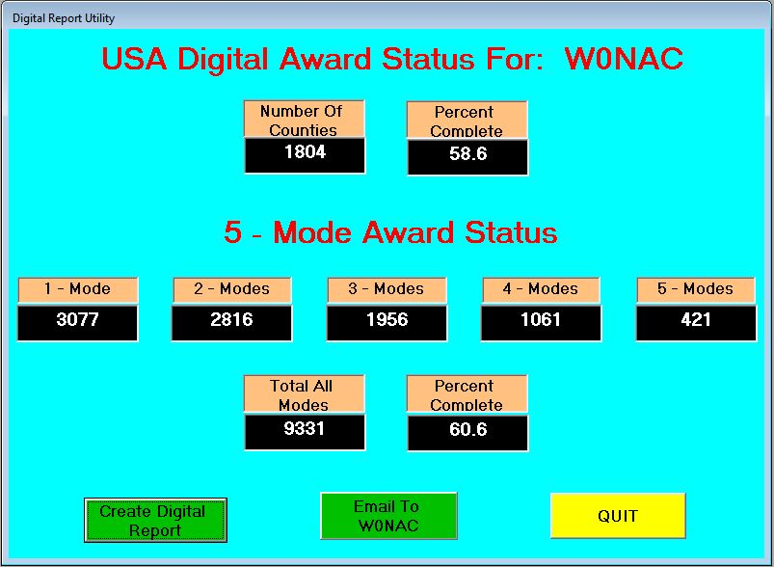
Once the report is showing on your screen and you are OK with the numbers, the program can also email your statistics to me so I can update Table 3. There is no longer a need for anyone to manually extract their statistics.
Installing and running the new utility is easy. Just download “Install Digital Report Utility Version 0.1.9.exe” from the MARAC Server ( http://www.marac.org/chdownloads ) or use the following Dropbox link (which is available 24/7) https://dl.dropboxusercontent.com/u/26171574/Digital%20Report%20Utility/Install%20Digital%20Report%20Utility%20Version%200.1.9.zip to get a zipped version of the same install file. You can save the file anywhere you wish on your computer (desktop, download folder, etc.) because it is not sensitive to location. When you execute this install file, just follow the default selections and it will install the new utility program in the proper folder (Program Files) and place an icon on your desktop that you can use to run it.
Please Note: When you first run the program you need to make sure that it is pointed to your call sign database file (files if you are an OM/YL team). This file(s) will usually be found in your “C:\Logger Data” folder.
To point the program to your file(s), press F-10 while on the opening screen (shown below). Then click on the button indicated:
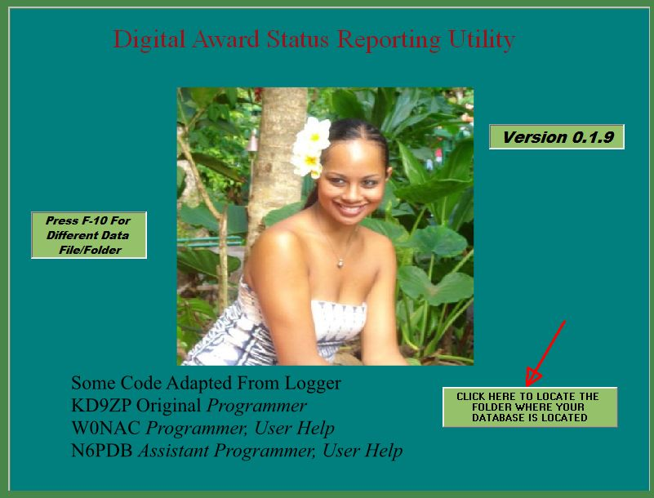
Then, use the following window (example below) to browse to your “Logger Data” folder and select your call sign database. Then click on the “Open” button.
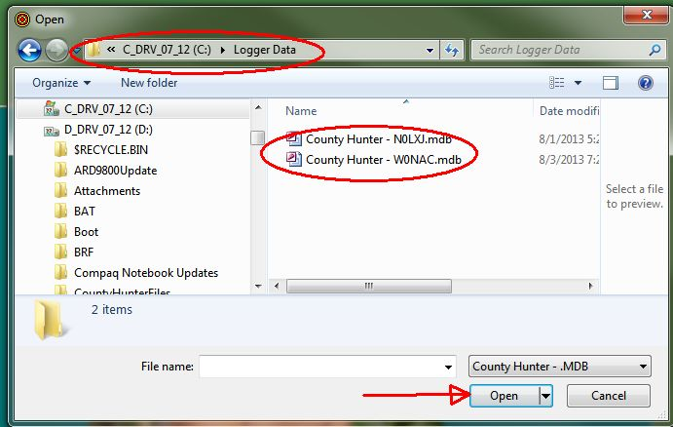
This will take you back to the opening screen with your call sign (two call signs if you are a team) displayed like this:
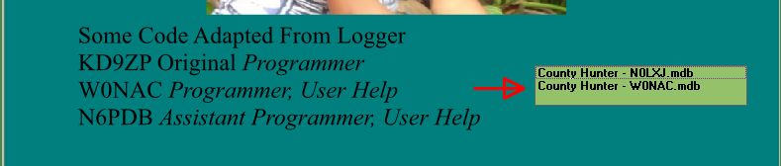
Clicking on your call sign will bring up the report screen where you can create your report and email it to me for updating Table 3.
Since it is nice and easy now, I encourage everyone listed on the table to use the new utility to email me current statistics NLT October 27th so I can get you up to date. If there are others not listed inTable 3 who would like their statistics included, just run the utility and have it email your numbers to me. I will get you listed!
During the month of September, 10 people have already used the new utility and emailed the results to me. These were: KG5RJ, N8CIJ, W7FEN, WD4OIN, W4YDY, WA4EEZ, NW6S, NA8W, KA8JQP, and N1API. I encourage those whose status is out of date (or totally missing) to download/install the new utility and use it to email updated status to me.
Caution: The email portion of this program may not work with every email client out there, especially web based email clients. If that part doesn’t work for you, just include your numbers in an email that you create manually using your own email client and send it to w0nac@comcast.net . Many Thanks!
Possible topics for the coming months include (in no particular order):
“How To Log Your Digital Contacts In Logger”
“Macros – Revisited”
“New Digital Awards?”
“Digital Software Installation – Revisited”
“Award Difficulty Index”
“Additional Digital Mode Test Results”
As always, I still need (and welcome) your suggestions on topics for future articles! Or if you have something you wish to contribute I will certainly try and include it. Short stories describing your experiences/frustrations/etc. in getting started in Digital ops would be especially welcome. Summaries of your Digital trips would also be good. I look forward to hearing from you.
Please email me with your comments/suggestions at w0nac@comcast.net and don’t forget to send me your updated status for the USA – Digital and 5 - Mode Awards so I can update the Digital County Hunter Status List again next month.
73’s and we hope to see you on our waterfall again real soon!
Matt – W0NAC

