DIGITAL HAPPENINGS #9
(April 2013)
By W0NAC (“Matt”)
Another month has slipped into oblivion! When one gets to be my age (80), time not only seems to pass more quickly, but the rate appears to accelerate! Oh well, we all know in our hearts that our lives are limited. We should all make our lives count for something while we have the opportunity, but also have some fun (county hunting?) along the way.
By the time you read this, Sharon and I will have completed a loop around Western Colorado. We are planning to put out the rest of the 17 Colorado counties I need to complete the 5-Mode State award. Sharon will hopefully complete most of the counties she needs for the 5-Mode State award also (still needs 3 in Eastern Colorado). Our complete trip plan was published on K3IMC’s County Hunter site as well as sent to many of you direct by email. I hope we made a lot of folk happy! Detailed results of the trip will be published next month.

Challenge Department:
Last month I challenged you to solve a new puzzle as stated below:
Can you connect all 9 dots in the figure below with just 3 straight lines without lifting your pen from the paper and never crossing over any of the lines?
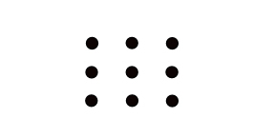
Four people (K4PBX – Jim, W6TPC – Harry, NX0X – Brian, and K1TKL – Paul) sent in correct solutions.
One correct solution is shown below: You will note that you have to really “think outside the box” to solve this latest problem. The key to solving this problem was to abandon the notion that your lines must go through the center of each dot!
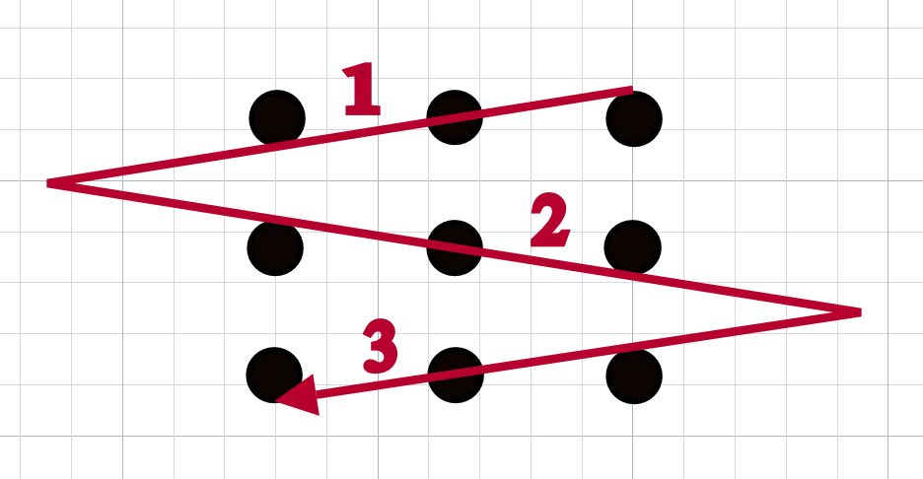

Now, I would like to challenge you again with a different problem:
What is the shortest word in the English dictionary that contains all 5 vowels once and only once and in exact alphabetical order?
I will provide a correct solution in next month’s article along with a list of who sent in a correct solution. Send your solutions to w0nac@comcast.net .

Digital Mode Tests:
As anyone who has tried putting out digital counties while mobile can testify, it is absolutely mandatory that you make the process as efficient as possible. Otherwise one can spend literally hours sitting in a county or on a county line and get almost nowhere travel-wise! A part of this optimization is your choice of the digital modes/sub-modes that you use. I have started a series of tests that will hopefully result in a short list of digital modes/sub-modes which are best for use when putting out digital counties while mobile.
Terry (WQ7A) and I ran over-the-air tests of 83 different digital modes/sub-modes to determine their Bandwidth, Time (seconds) to pass 100 characters, Words/Minute, and recorded general comments on delays, copy, etc. The list of 83 modes/sub-modes was developed by listing every “Op Mode” option available in the latest version (3.21.70) of Fldigi. If you would like to review the detailed results of this test, you can download them from: https://dl.dropboxusercontent.com/u/26171574/Modes_Submodes%20Test%2002.xlsx .
The Bandwidths observed ranged from a low of ~40 Hz for BPSK-31 to a maximum of 2200 Hz for Feld Hell X9. Time to pass 100 characters ranged from a minimum of ~2 seconds (600 WPM) for BPSK-1000 to a maximum of 290 seconds (4.1 WPM) for Slow Hell. In other words, speeds ranged from blindingly fast to “slower than molasses in January”.
Based on these results I selected 18 modes/sub-modes which warrant further testing (shown below)
Mode/Sub-Mode Candidates
Mode Sub-Mode #1 Sub-Mode #2 Sub-Mode #3
CONTESTIA | 8/1000
DOMINOEX | 16 | 22 | 44
HELL | 80
MFSK | 31 | 32 | 64
OLIVIA | 8/1000
PSK | BPSK-63 | BPSK-125 | BPSK-250
RTTY | 45 | 75N | 75W
THOR | 22
THROB | 4 | X4

Sharon and I will have used as many of these modes/sub-modes as we can on our Colorado trip. How our “on-the-road” tests turn out will be reported on next month. Hopefully, I can pare this list down some more based on our test results and offer some recommendations at the Digital meeting next July in Deadwood.

Now on to the main topic for this month….
Other Interesting Digital Modes:
I will start with the JT-65 Mode. This mode was originally created by Joe Taylor (K1JT) and a friendly user interface has been created by W6CQZ. A screen shot of this mode in real time operation is shown below:
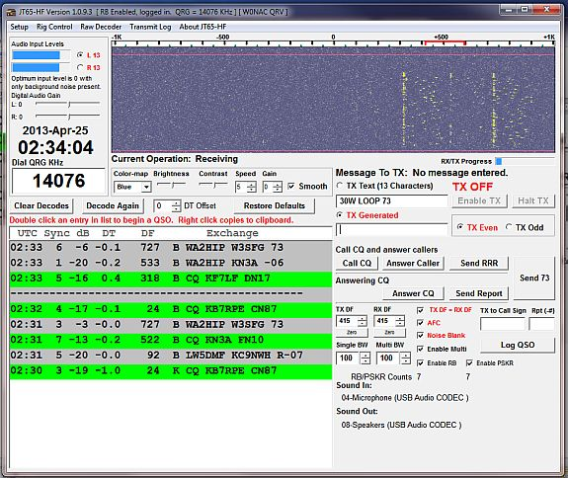
JT-65 is a very interesting mode! It is growing in popularity almost daily. It uses very “canned” exchange messages which (if free text) are restricted to 13 total characters from a restricted pallet of upper case letters, numbers, and a few other special characters. Each pre-formatted exchange takes exactly 60 seconds to complete. 48 seconds are used for transmitting (or receiving) the data. The other 12 seconds is used for decoding the data sent or received during the previous 48 seconds.
A total of 5 exchanges are normally done to complete a contact. They might go something like this:
1) CQ KB7RPE CN87
2) KB7RPE W0NAC DM79
3) W0NAC KB7RPE -05
4) KB7RPE W0NAC -04
5) W0NAC KB7RPE RRR
6) KB7RPE W0NAC 73
The 6th exchange is not required to complete a valid contact, but is usually sent as a courtesy. One can get a little creative with this 6th exchange also and send some free text like “30W LOOP 73”.
JT-65 is an excellent weak signal mode! You can reliably decode signals that are as much as -25 dB below the noise. This makes it very useable when you have small antennas, operate with low power, and live in a high noise area. In other words, if you live in a condo/apartment with CC&Rs that limit you to “stealth” antennas, low power, etc., this is the mode for you as it will work when SSB or even CW won’t!
There is an excellent piece of free software called “PSK Reporter” (It works well for JT-65 and other modes also). This software organizes data from a very large number of “reverse beacon” stations which are listening for digital signals on all bands 24/7. A screen shot of this program in operation is given below:
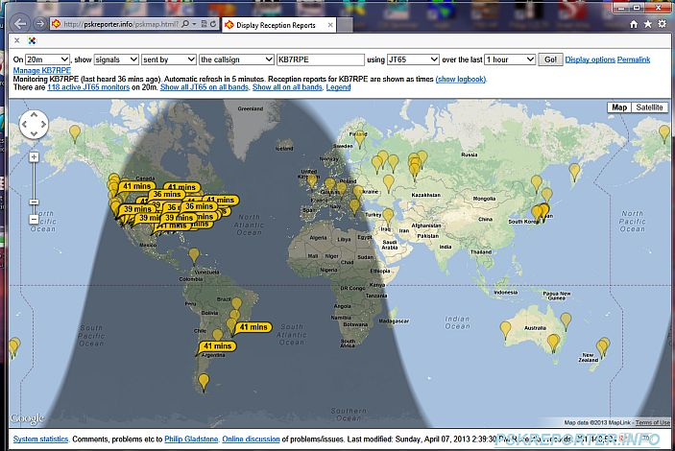
I set this up to display all signals sent by KB7RPE using JT-65 over the last 1 hour that were received by a monitoring station. All 118 stations monitoring JT-65 signals on 20 Meters are shown in pale yellow balloons. Those who received KB7RPE’s JT-65 signal are shown with darker yellow flags containing time since last heard. You can see that KB7RPE is being heard all over the USA plus 2 monitors in South America heard him.
You can set up PSK Reporter to report on your own signals after putting out a CQ. You will be amazed at how far away you can be heard and decoded when using only a simple antenna and a few watts!
You might ask why I am recommending this mode for use by county hunters. After all, at first glance it appears to be wretchedly slow. My reply is that it is obviously pretty much useless for putting out counties when operating mobile (too slow). However, if you only wish to troll for new counties (when you are fixed or mobile), JT-65 can yield excellent results. If you are a fixed station working mobiles on the County Hunter Net, you might complete 6 to 8 contacts per hour. The exact number depends on how long the runs are. The percentage of these contacts that are “new” counties will vary widely depending on how close you are to finishing any particular award, but the number will generally be low.
By comparison, you can complete as many as 6 – 10 contacts per hour using JT-65. Yes, most of these will be fixed stations or DX, but many of them may be located in counties you need. Also, there seems to be a very large number of stations using JT-65 these days (on all bands from 160M – 10M) and usage is growing. I have been working JT-65 for some months now and seldom encounter a duplicate call sign. If you use it for “trolling” for new counties, I believe you will be pleasantly surprised.
If you are interested in DX, JT-65 is very popular all over the world. There are many DX stations using this mode and signals will usually get through even under the worst of conditions.
Next, I will briefly discuss a brand new digital mode by the name of JT9. JT9, like JT-65 was also created by Joe Taylor (K1JT). Unlike JT-65, JT9 has 5 sub-modes (JT9-1, JT9-2, JT9-5, JT9-10 and JT9-30). These sub-modes use 1, 2, 5, 10 and 30 minutes respectively for one exchange. Of these sub-modes, JT9-1 is the most popular right now and uses only 10% of the bandwidth of JT-65.
To complete a valid 5 exchange contact using JT9-30 would take 2 ½ hours! However, the signal produced by this mode is only 0.4 Hz wide! Also, extremely weak signals can be decoded which are -40 dB below the noise. The user interface consists of a waterfall/signal display and a control panel. They look like this on your screen:
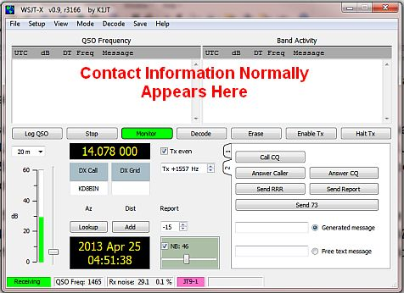
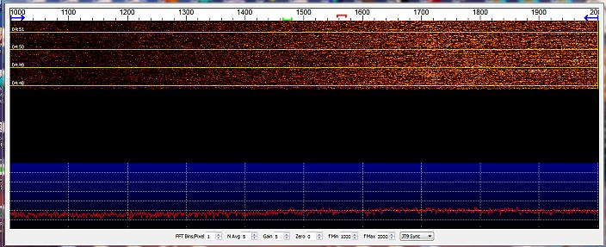
These screens show no signals because it was 0500Z when they were captured and the 20M Band was totally dead at the time.
I don’t have as much experience yet with JT9 as I do with JT-65, but I believe it will be another excellent county hunter “trolling” mode similar to JT-65. If the specifications prove out, it should be perhaps the best DX mode you can use! Time will tell…
JT9 is so new that it is not an “approved” mode for purposes of the new 5 – Mode Award. However, a proposed change to the MARAC rules is in process which will add JT9 to the approved list. If all goes well, this change may be on the Board agenda for approval at the next national in Deadwood. In the meantime, you can still make and log (on paper) any JT9 contacts you make. When the change is approved and Logger is changed, you should be able to apply these toward the 5-Mode Award.
Here are some links you may find useful if you wish to experiment with either JT-65 or JT9
1) Download JT-65 Setup - http://hfradio.org.uk/ . This brings up G4UCJ’s welcome page. Scroll down a bit
until you see the picture for JT65-HF. Click on picture to
download setup file.
2) Download JT-65 Manual - http://openhpsdr.org/wiki/images/0/0c/Jt65-hf-setup.pdf
3) Download JT9 Setup/Manual – http://physics.princeton.edu/pulsar/K1JT/wsjt.html This link will take you to the WSJT Home Page – Scroll down to “Downloads” where you will need to click on two items:
a) “WSJT-X User’s Guide”
b) “Windows WSJT-X (v0.9, r195)
And then scroll down to “User’s Guide and Reference Manual and click on “English”
JT-65 is relatively easy to set up, but JT9 setup can be a little confusing because it is a selectable mode using the WSJT-X interface software. Call me (303-799-3658) if you have any problems you can’t figure out for yourself. I’ll be pleased to try, but results are not guaranteed as I am not an expert, particularly with JT9.
Both JT-65 and JT9 require that your computer clock be accurate to a second or less from true time. You will need a clock synchronization program to do this as computer clocks are notoriously inaccurate if left to their own devices. The program I use and recommend is “Time Sync” at http://ravib.com/timesync/ .
April Activities:
Activities during April slowed down a bit from March. WA4UNS (Doug) put out a lot of digital counties in VA, NJ, and MD during late April. He used PSK-63, RTTY, and MFSK-16 on his runs. Good Job, Doug! W0NAC and N0LXJ will be putting out digital counties on 26 – 28 April in Western Colorado. We will be using several new modes/sub-modes as part of a test described earlier.
I have helped several people during April including WY8I and VK4AAR. As always, I stand ready to help anyone who has problems or wishes to get started with digital operations. Just email me or call me on the phone. My email is w0nac@comcast.net and my home phone number is 303-799-3658. Call any time.
Table 3 (below) has again been updated from last month. If I have left anyone off the list you have my sincere apology! Just drop me a quick email and include your stats, if you know them, and I will be pleased to add you to the list. Conversely, if you are on the list and feel that you don’t belong, please also drop me an email and I will remove you.
Logger will currently give you your status for the USA – Digital Award (go to “View/Edit/Book/USA-Digital/All”), but for the 5 - Mode Award, Logger only reports those counties which have been worked using all 5 different modes. You can see your 5 - Mode Award status by going to “View/Edit/Book/5 - Mode/All”. A fix is still in the works that will report on the status of 1, 2, 3, and 4 completed counties also, but it may be quite a while before this is released. While waiting, the 1, 2, 3, and 4 completed county columns for the 5 - Mode Award may have to remain blank for most people. If you can ZIP up and send me your call sign database file (mine is named “County Hunter – W0NAC.mdb”) I will manually determine how many counties you have completed for 1, 2, 3, 4, and 5 modes and place your numbers in Table 3. However, be sure you have recently recalculated both your 5 – Mode book and USA – Digital book before sending your file.
I am still in the early stages of establishing an interactive web site for digital matters. One of the functions I hope to have on the site is an interactive way for digital folk to input their status so I can update the table. I have a server and a domain name, but still need to develop the software for the site. It may be a couple of months before the site is up and fully functional.
Here is the updated Table 3:

Possible topics for the coming months include –
“How To Log Your Digital Contacts In Logger”
“Macros – Revisited”
“New Digital Awards?”
“Digital Software Installation – Revisited”
“Award Difficulty Index”
“Digital Mode Test Results”

So long again…..Please email me with your comments/suggestions at w0nac@comcast.net and don’t forget to send me your counties worked status on the USA – Digital and 5 - Mode Awards so I can update the Digital County Hunter Status List again next month.
73’s and we hope to see you at the National Convention in Deadwood.
Matt – W0NAC

