DIGITAL HAPPENINGS #8
(March 2013)
By W0NAC (“Matt”)
Well guys and gals, another busy month has just flown by! Sharon and I were not able to go mobile and put out new digital counties this month. However, we are planning to put out the rest of the 17 Colorado counties I need for the 5-Mode award and the 20 counties I still need for Xmitted Counties – MP (Most of these are the same counties). Sharon still has digital needs in Colorado also. We will probably make this trip in early April. I will publish our detailed trip plan after it is firmed up.
N6PDB and WA6OCV (Dennis and Susan) more than made up for our lack of activity in March by making an extended trip in their 27’ Winnebago motor home. They covered 6700 total miles and put out 176 counties in CA, AZ, NM, TX, OK, LA, MS, and AR. They transmitted using digital modes from 174 of these counties! They made a total of over 5000 contacts of which ~ 427 were PSK, ~536 RTTY, and ~430 were MFSK. Dennis reports that they really had a ball doing this! To my knowledge, this is the longest sustained run of counties put out digitally made by anyone, let alone an OM/YL team. Congratulations to both of you!!
During the course of the trip, Dennis experienced some of the same difficulties that Sharon and I have encountered putting out counties digitally. He says that the main thing they learned is that digital mobile operations must be made more efficient! To accomplish this, people working digital mobiles must “terse up” their macros to be as short as legally possible. Also, 1 or 2 CR/LFs at the beginning of each macro will space your text down from other garbage that may be on the mobile’s screen. Dennis also experienced the same pile-up problem that we have observed before. Since digital modes don’t seem to exhibit any capture effect, two or more stations transmitting on the same frequency at the same time will decode only garbage on the screen. Also, the “meat servo” (brain) filters that many of us have developed over the years for SSB and CW pile-ups don’t work for the digital modes. These subjects (and others) are on the agenda for the digital meeting scheduled on Saturday at the National in Deadwood.
In spite of all these difficulties and frustrations, Dennis reiterated that they had a really good time on the trip. After all, isn’t this the most important thing? I (and probably others) have always said that “If it isn’t fun, you should probably find something else to do!”

Last month I challenged you to solve a little puzzle. Three people (WQ7A – Terry, K1TKL – Paul, and W4SIG – Kerry) sent in a correct solution. One correct solution is shown below: You will note that you have to “think outside the box” to solve this problem.
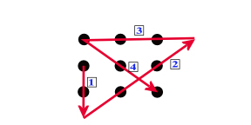
Now, I would like to challenge you again as follows:
Can you connect all 9 dots in the figure below with just 3 straight lines without lifting your pen from the paper and never crossing over any of the lines? Shown below are a wrong solution (used 4 lines and crosses one line) and a blank matrix which you can copy. Remember, you need to do this with only 3 lines this time. Hint: Read the challenge statement very carefully! I will provide a correct solution in next month’s article along with a list of who sent in a correct solution. Send your solutions to w0nac@comcast.net .
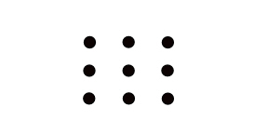

Now on to the main topic for this article:
FLDIGI OPERATING TIPS
First, let me say how pleased I am with this free software! Yes, like all software, it has a “bug” or two. For example, the latest version (3.21.68) occasionally quits with no warning. This can be especially irritating if you are in the middle of a mobile run, but no data seems to be lost and a quick re-start gets you right back in business. This issue has been posted on the Fldigi support forum, so I expect this problem to be fixed soon. Meanwhile, as I learn more about the program, I like it more and more.
I strongly encourage you dig into the Fldigi manual. It is loaded with excellent information. You can download it from the Fldigi site at http://www.w1hkj.com/download.html by clicking on the “fldigi manual (pdf)” link. The file “fldigi.pdf” is a little over 8 Mbytes in size so plan on several minutes to download it. It can be opened and read or printed using Adobe Reader that everyone has on their computer.
The Fldigi manual is 146 pages long. Any comments I make on Fldigi operation in this short article are not intended as a substitute for reading the manual, but there are several things I have learned about using the program for county hunting that you may find useful. I will be referring to various boxes and buttons on the following main Fldigi screen shot for further discussion. These are labeled A through M on the photo.
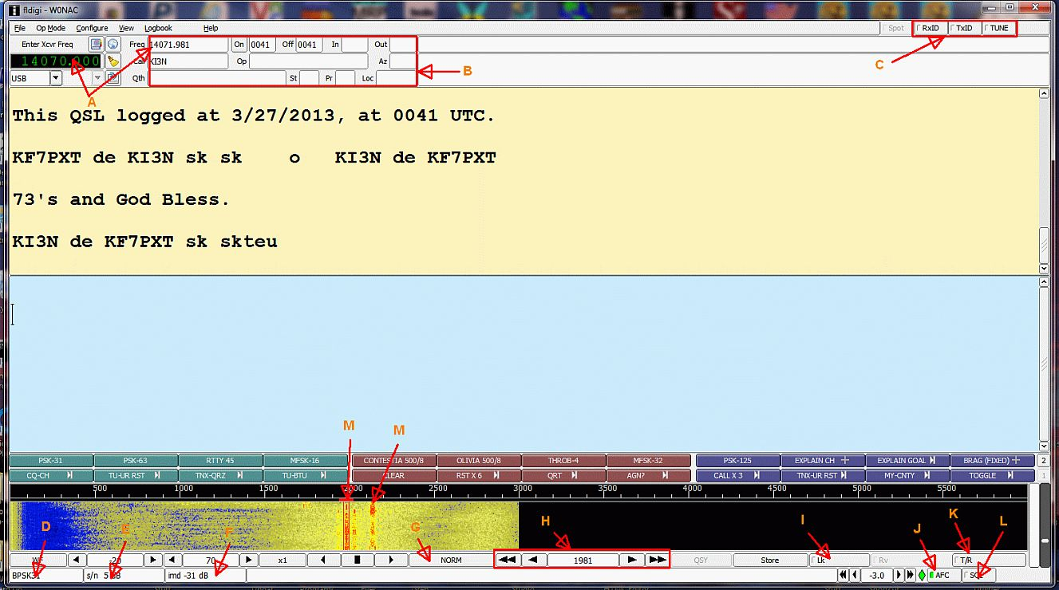
A. Finding a Spotted Mobile Station. This seems to be a very common problem, especially with people just getting started with digital operations. First, note the box labeled “Enter Xcvr Frequency”. This box must contain your transceiver dial frequency setting. If you have “CAT” active, this box will be automatically updated with whatever shows on your receiver dial. However, if you do not have “CAT” (the SignaLink USB interface I have recommended in the past does not support “CAT”), you will need to update this box manually. You do this by Left or Right clicking on any of the numbers. A left click will increase the number and a right click will decrease the number.
Now, note the other box labeled “Freq”. Fldigi calculates you’re “True” transmit/receive frequency and displays it in this box. It does this by adding the offset of where you are tuned on your waterfall to the dial setting in the first box. You can also do this calculation in your head, but be careful of the units. Most transceiver dials display frequency in MHz, but Box #1 displays frequency in KHz and the waterfall is calibrated in Hz! On the screen above, the transceiver dial is set to 14070.000 KHz. The waterfall offset selected is 1,981 Hz (or 1.981 KHz). When added together, you get your true operating frequency of 14071.981 KHz. Simple, huh?
Once you understand this principle, finding a mobile station is easy. You simply work backwards from what I did above. Let’s say that N6PDB/WA6OCV are spotted in Podunk county on 14074.3 KHz (spots always state “true” frequency for mobiles operating in digital modes). The main question is: “Where should I set my transceiver dial?“ The best answer is 14.0730 MHz. If you set your dial to 14.0730 MHz then Dennis and Susan should display at 1430 Hz offset on your waterfall. If you were to set your dial to 14.0743 MHz (their spotted frequency), you will never see/hear them because their waterfall offset will be 0! Your sound card will not pass signals much below 300 Hz or above about 2500 Hz. For this reason I like to keep signals I’m working displayed on the waterfall between 500 and 1500 Hz offset.
B. QSO Buffer/Logging Values: The red box indicated by “B” contains a variety of values that are used for logging QSOs and for <TAGS> which can be used to insert these values in a macro. I have already discussed the “Freq” box. The other boxes contain the following:
“Call” - > The other stations call sign
“Qth” - > The other stations QTH
“On” - > Start Time of QSO
“Off” - > End Time of QSO
“Op” - > Their Name
“In” - > RST Received
“Out” - > RST Sent
“St” - > Their State
“Az” - > Azimuth
“Pr” - > Canadian Province
“Loc” - > Maidenhead Locator
The “Call” box can be filled three different ways:
1) You can double click anywhere on a call sign displayed on the receive screen (but it must be isolated).
2) Manually highlight a call sign on the screen by clicking and dragging the mouse, then right clicking on the highlighted call and selecting “Call” from the pop-down menu.
3) Simply click in the box itself and manually type in the call sign
Of the three, the first method is much faster, but decoding doesn’t always give you an isolated call sign to click on! Personally, I seldom use any of the other boxes in county hunting. They are simply not needed.
C. RSid and Tune Group. People often ask me how they can tell what mode is being used when they tune to a digital signal. I do it in a number of ways. First, each mode has its own distinctive sound. With experience, you can do pretty well just listening. Also, there is a neat site you can go to which has short audio clips for each mode plus other characteristics. You will find it at http://hfradio.org.uk/html/digital_modes.html . Sometimes you can distinguish modes by the bandwidth they occupy and how they look on the waterfall. One of the newer means of identifying modes is the Reed Solomon Identifier (RSid). RSid is a small video identification of the mode being used that displays on the waterfall. The “RxID” button toggles the reception of RSid identifiers and the “TxID” button toggles your own transmission of RSid identifiers. Needless to say, the person on one end of the QSO must be transmitting RSid and the other person must have “RxID” turned on to receive them. If both persons have both “TxID” and “RxID” turned on, both will see each other’s identifiers. There is more to it than I have room to explain here. Again, please consult the Fldigi manual for more information.
The “Tune” button is for just that. It will turn your transmitter on and modulate your signal with a single steady tone. This is the button you should use when adjusting your transmitter RF output level. Remember, set your transceiver RF output control to 100% and gradually increase the audio input going to the transceiver (if you have a SignaLink USB interface you will turn up the “TX” control) until you just see a little of ALC action. Then back the audio off a bit until all ALC action disappears. On a typical 100W transceiver, this will give you an undistorted power output of around 40-50 Watts. Pushing your transceiver harder will not help the other guy copy you any better and it could damage your final amplifiers. Most digital modes operate with nearly a 100% duty factor. This is like putting a brick on your key in CW!
D. Mode Box. This box always displays your current operating mode.
E. s/n Box. When tuned to a digital signal, this box will display the signal/noise ration of the received signal. When you are in the CW Mode, this box displays the transmit WPM which can be adjusted faster or slower with small arrows on either end of the box.
F. imd Box. When tuned to a digital signal, this box will display the “IMD” or intermodulation distortion present on the signal. What it actually tells you is how far your second harmonic products are below your main signal in dB (minus). There is a lot of folk lore about what IMD is good and what IMD is bad, but usually any reading of -20 dB or lower indicates an acceptable signal quality. However, to get an accurate reading, the signal you are checking should be modulated with a steady tone and be reasonably strong (low s/n).
G. Waterfall Speed. Clicking on this button toggles the Waterfall speed from NORM to FAST to PAUSE to SLOW and back to NORM.
H. Offset Fine Tuning Controls. The center of this box displays the exact offset of your tuning bracket in Hz. If you need to fine tune on a signal in order to make it decode properly, you can click on the left and right single arrows to decrease or increase your offset by 1 Hz/click. The left and right double arrows will decrease or increase your offset by 10Hz/click. These controls give you better and smoother control of tuning than you can achieve with the mouse.
I. “Lk” or Lock Button. This button toggles locking of your transmit frequency ON and OFF. With your transmit frequency locked, you can tune your receive frequency up or down as much as you wish. In other words, it is a form of what most transceivers call Receiver Incremental Tuning or RIT. If the operators on both ends of the QSO leave their transmit frequency unlocked, you can end up “chasing” each other up or down the waterfall as one (or both) of your transmitters drifts in frequency. In county hunting it has become the custom for the mobile to lock their transmitter and then tune their receive bracket up or down a bit to decode the signals of those calling. However, you need to know that every time you change to a new mode, the transmit lock is automatically released and has to be re-applied if you want your transmit frequency locked in the new mode.
J. “AFC” Button. This button toggles automatic frequency control ON and OFF. For most digital modes I believe you will find it advantageous to turn AFC ON. Especially for the modes where exact tuning is critical, AFC can help a lot!
K. T/R Button. Clicking on this button is another way to toggle between Transmit and Receive. You need to know about a neat little trick. While you are decoding another signal (in receive mode), you can click anywhere in the Transmit screen to activate a cursor and then you can type in a reply while still receiving the other person’s text. This preformed text is just stored in a buffer until you switch to transmit. Then, it immediately starts being transmitted. Another little trick… If you have some text typed into the transmit window and click on a macro that also contains text, the preformed text in your transmit window will be sent first and then the macro text will be sent. In other words, this trick allows you to type anything you might wish to send out before the macro text is sent.
L. Squelch Button. This button toggles squelch ON and OFF. In the past, I have usually left it OFF. But, if one does this, you have to put up with a lot of garbage decoded to the screen from random noise. If you wish to try using it, first toggle squelch ON (little light in the button illuminates) and then adjust the slider bug in the rightmost vertical bar starting with it all the way to the bottom. The next bar to the left has a green signal strength indicator which sits pretty close to the bottom if there is no signal. As long as the squelch slider bug is higher than the level of incoming signals, garbage on your screen will be suppressed. If a signal comes along that is stronger than the squelch level you have set, it will start decoding. I can see where squelch may help in county hunting, but I haven’t used it enough to form a firm opinion yet.
M. Another Neat Trick. Terry (WQ7A) pointed out a technique you may find to be very useful. Let’s say that you are tuned to one signal (on the illustration screen it is the stronger signal pointed to with “M”) and you see another signal pop up at a different offset on the waterfall (on the illustration screen it is pointed to by the other “M”). If you want to see what the other signal is saying, move your mouse to the 2nd signal and right click on it and hold the button down. As long as you hold the right click button down, Fldigi will decode the second signal. When you release the right button, Fldigi will immediately go back to the original signal and resume decoding it again. If you also hold the <Control> key down before right-clicking, Fldigi will first decode all of its buffered audio at that frequency.
N. Colors and Font Control. If you click on “Configure” and then select “Colors and Fonts”, then click on the Rx/Tx Tab, you will see a screen like the following:
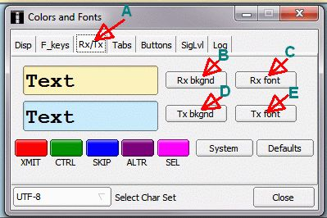
Using the controls on this screen you can tailor Fldigi’s receive and transmit screens so that they are much easier to read. The default font size is just too small for my tired old eyes! If you have the same problem (and most of us do when we get older), these adjustments can make all the difference! The way this operated is pretty intuitive so I won’t go into any more detail here (go to the manual if you need to). I will tell you that I use 28 point font size! It helps a lot.

To summarize, I find that the longer I use Fldigi and explore its features, the better I like it. Perhaps next month I can point out a few more neat things you can do with this program.
MARCH ACTIVITIES:
During March there was quite a flurry of support activity. Many county hunters have apparently decided to “take the plunge” into digital operation and needed some help setting up their rigs. Almost every one presented a different challenge because they were using different transceivers, interfaces, and computers. Even so, it was fun helping to get them operating on the digital modes. Seeing all these new additions to active digital county hunting was very gratifying! Just a few of the folks I helped were N6PDB, WQ7A, N9WNN, W3DLM, N1API, and NW6S. Also we need to welcome two new mobile teams operating digital. They are N6PDB/WA6OCV (Dennis & Susan) and NA8W/KA8JQP (Darl & Pamela). Including Sharon and I that makes 3 mobile teams active on digital now.
As always, I stand ready to help anyone who has problems or wishes to get started with digital operations. Just email me or call me on the phone. My email is w0nac@comcast.net and my home phone number is 303-799-3658. Call any time.
Table 3 (Below) has again been updated from last month. If I have left anyone off the list you have my sincere apology! Just drop me a quick email and include your stats, if you know them, and I will be pleased to add you to the list. Conversely, if you are on the list and feel that you don’t belong, please also drop me an email and I will remove you.
Logger will currently give you your status for the USA – Digital Award (go to “View/Edit/Book/USA-Digital/All”), but for the 5 - Mode Award, Logger only reports those counties which have been worked using all 5 different modes. You can see your 5 - Mode Award status by going to “View/Edit/Book/5 - Mode/All”. A fix is still in the works that will report on the status of 1, 2, 3, and 4 completed counties also, but it may be quite a while before this is released. While waiting, the 1, 2, 3, and 4 completed county columns for the 5 - Mode Award may have to remain blank for most people. If you can ZIP up and send me your call sign database file (Mine is named “County Hunter – W0NAC.mdb”) I will determine how many counties you have completed for 1, 2, 3, and 4 modes and place your numbers in Table 3. However, be sure you have recently recalculated both your 5 – Mode book and USA – Digital book before sending your file.
I am still in the early stages of establishing an interactive web site for digital matters. One of the functions I hope to have on the site is an interactive way for digital folk to input their status so I can update the table. I have a server and a domain name, but still need to develop the software for the site. It may be a couple of months before the site is up and fully functional.
Here is the updated Table 3:

Possible topics for the coming months include –
“How to log your digital contacts in Logger”
“Macros – revisited”
“New digital awards?
“Other Interesting digital modes (JT-65, JT-9)”
“Award Difficulty Index”
So long again…..Please email me with your comments/suggestions at w0nac@comcast.net and don’t forget to send me your counties worked status on the USA – Digital and 5 - Mode Awards so I can update the Digital County Hunter Status List again next month.
73’s and we hope to see you at the National Convention in Deadwood.
Matt – W0NAC

