DIGITAL HAPPENINGS #7
(February 2013)
By W0NAC (“Matt”)
Over the weekend of February 15 – 17 Barry (N0KV) and I (W0NAC) made a loop from Colorado through Kansas and Oklahoma then back home. We put out 17 total counties on 3 digital modes each. We both also put out all counties on SSB and Barry put out many of them on CW. Because of the length of time spent on operating digital we spent close to an hour on most county lines. This cut back some on our total county count, but we seemed to be making quite a few people happy, so we persisted. On Sunday (17th) the insulator at the base of my antenna started arcing and became carbonized. Even though we could still hear other stations, the tuner was seeing an almost dead short on transmit and refused to load. Since repairing this on the road was not feasible, we just “headed for the barn” and got home about 10 PM Sunday night. We did miss putting out several counties in Oklahoma and Colorado as a result, but really had no choice. Later in this article I give a detailed analysis of the digital results, but here are a few highlights.
Over the 3 days Barry and I put out 25 total counties, of which 17 were on 3 digital modes. Most of these counties were put out while sitting on county lines. We made a total of about 2000 contacts (counting each of us as separate contacts) of which over 600 were digital. The remaining 1400 were mostly SSB on 14.336 with quite a few CW put out by Barry. On a typical county line run we would make as many as 45 QSOs on SSB (180 loggable contacts) followed by 3 to 10 QSOs each on PSK-63, RTTY, and MFSK-16 (36 to 120 loggable contacts). Even though Barry “tersed up” our macros, doing all this still took almost 1 hour per county line. Obviously there is still a long way to go in making digital operations faster. I am convinced that using faster modes is part of the answer. We did experiment with using MFSK-32 (twice as fast as MFSK-16) and liked the way it worked, but only time will tell if it will be a better mode. A digital meeting is being scheduled on Saturday at the National in Deadwood. This will be a good time to discuss ways to make digital operations more efficient. Your ideas will be welcomed!
This leads into the main topic for this article:
SELECTING MODES & RAPID MODE CHANGES USING MACROS
Before getting into the “meat” of this topic you need to know how many different modes are approved for use by county hunters when making contacts that count for the new USA – Digital and 5 – Mode Awards (the answer is 33). Some of these modes have sub-modes. One mode (PSK) has 14 sub-modes! There are other sub-mode variations, but most sub-modes are based on baud rate, number of tones, or bandwidth. Shown below is Table 1 that lists all 33 modes and most of their common sub-modes. Whether they are a digital or analog mode is also shown. Only digital mode contacts (excluding CW) may be counted toward the USA – Digital Award, but ANY 5 of the 33 modes may be used for the 5 – Mode Award (each county can have a different set of 5 modes). Also, for purposes of county hunting, all sub-modes of the same mode count as the mode itself, not different modes.
TABLE 1: COUNTY HUNTER AUTHORIZED MODES + SUBMODES
The natural question to ask at this point is “Why all these different modes?” or “What are they good for?”. I can hear some of you saying “I’ll just stick to good ol’ SSB or CW!” My answer to those who feel this way is that it may be time to start “thinking outside the box”.
Just for “grins”, I would like to challenge you to solve a little puzzle. Can you connect the center of all 9 dots in the figure below with just 4 straight lines without lifting your pen from the paper? Shown below is a wrong solution (used 5 lines) and a blank matrix which you can copy. Remember, you need to do this with only 4 lines. I will provide a correct solution in next month’s article.
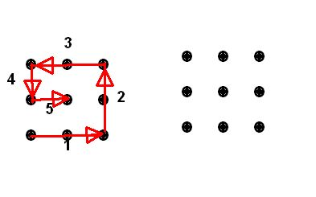
The principle advantages of using the new digital modes (as opposed to using SSB or CW) are:
1) Smaller Bandwidth – This allows for better use of available spectrum. For example, a PSK-31 signal is only ~40 Hz wide where a typical SSB signal is ~2800 Hz wide. Allowing for 20 Hz spacing between signals, one could have as many as 40 PSK-31 signals in the same bandwidth occupied with just one SSB signal! Other digital signals are wider, of course, but essentially all are narrower than SSB.
2) Improved Signal-To-Noise – I have observed over years of use that PSK-31 is as good (and maybe a bit better) than CW for working signals that are “down in the mud”. As a result, It has a much better weak signal capability than SSB. There seems to be an inverse relationship between a mode’s bandwidth and its S/N capability. For example, if one operates PSK-63 instead of PSK-31, the bandwidth doubles to ~ 80 Hz and you lose S/N capability by about 3 dB. If you go to PSK-125, the bandwidth doubles again to ~160 Hz and another 3 dB loss in S/N capability theoretically occurs, but PSK-125 still seems to be more sensitive than SSB. The JT-65 mode (which is becoming ever more popular) can copy signals that are up to 25 dB under the noise. A newer mode (JT-9-30) can work signals up to 40 dB below the noise and it is only 0.4 Hz wide! Of course, each transmission takes 30 minutes to complete!
3) Forward Error Correction (FEC) – Several digital modes incorporate FEC which can greatly improve decoding accuracy during weak signal reception. For example MFSK and JT-65 use FEC. However, there is almost always a negative aspect to every improvement. In the case of FEC there can be a delay before decoding starts. This delay slows down the “rapid fire” exchanges that county hunters need. Also, the overall data transmission rate is slowed somewhat by having to repeat sending data that fails the error check.
4) Needed For USA – Digital and 5 – Mode Awards – Admittedly this need is self-evident, but pursuing the USA – Digital Award requires that you make at least one digital mode (Except CW) contact in each county. Since ANY of the 33 modes in Table 1 above can be used for the 5 – Mode award and there are 5 analog modes, one could theoretically complete the 5 – Mode Award and never use any of the digital modes. However, as a practical matter, one will need to use at least 2 or 3 digital modes for most counties.

Now for the “meat”….

Setting Up For Different Modes – Almost all modern digital modes use a soundcard (internal or external) controlled by software to receive and transmit digital signals. There are many different software choices out there. Most can operate using multiple modes and some support only one mode (like JT-65). Each of those that support multiple modes has their own methods for changing modes. I cannot possibly cover all these software choices in this article, so again, as in previous articles I will limit my discussion to just Fldigi. If you wish to download Fldigi it is available for free at the following link: http://www.w1hkj.com/download.html . Below is a screen shot of the main Fldigi screen which I will use when describing how to change modes.
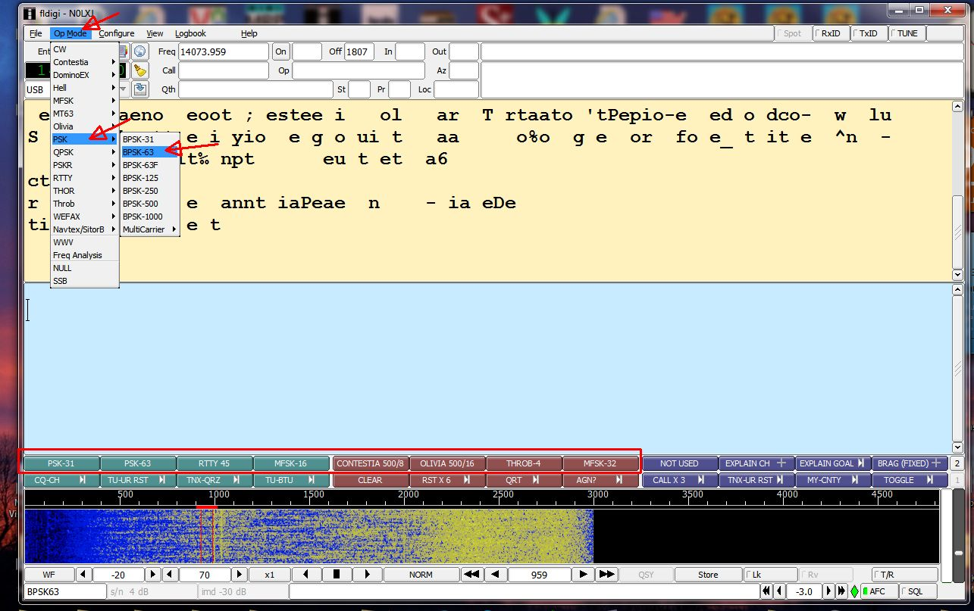
The first method of changing modes is by using menu selection. Here, you use your mouse to click on the “Op Mode” selection at the top left of the screen. A drop down menu will then display which contains each of the main modes of which Fldigi is capable of operating. Simply drag your mouse pointer down to the desired mode and, if this mode has sub-modes, a list of available sub-modes will appear to the right. Next you want to move your mouse pointer straight right into the sub-mode selection window, then up or down until the desired sub-mode is under the pointer (it will be highlighted). Left click on the sub-mode selected and your configuration will be complete. The example given above selects PSK-63. Please note that the Fldigi operating mode/sub-mode is always displayed in the bottom left corner of the screen. You can use this box to verify that you have successfully changed to the desired mode.
The second method of changing modes is by use of a preset macro button. I have set up 8 macros which will instantly switch to some of the more commonly used modes/sub-modes with a single mouse click. These are outlined in red just above the waterfall. To use macros for mode/sub-mode switching requires that they be set up in advance. I have done this for you already. All you need do is download the file “Fldigi Macros 02-26-2013.zip” by clicking on this link: https://dl.dropbox.com/u/26171574/Fldigi%20Macros%2002-26-2013.zip . Save this file into a convenient folder and expand it into the following folder: “C:\users\<username>\fldigi.files\Macros”. You should end up with four macro files named:
1) “Casual QSO Fixed.mdf”
2) “County Hunter Fixed.mdf”
3) “County Hunter Mobile.mdf”
4) “County Hunter Mobile Team.mdf”
In each of these four macro files, the first 8 buttons in the second set of 12 are programmed to rapidly change to one of the more popular mode/sub-modes. If you need additional or different mode selections, you can either modify one of the existing macro buttons in set 2 or define new ones in set 3 or 4. There is currently room to add up to 22 new mode/sub-mode macro buttons.
If you need a refresher on creating or modifying macros, a review of “Digital Happenings #6” published in the February Roadrunner may help.

Earlier I promised more detailed results from our 3 day loop through CO, KS, and OK. The following table shows everyone who made any digital contacts with us and how many contacts they made (1 QSO = 4 contacts if we were on a county line) by mode:
Table 2 – DIGITAL CONTACTS WITH W0NAC/N0KV ON KANSAS LOOP FEBRUARY 2013

We really do thank everyone for their support on this trip!

FEBRUARY ACTIVITIES:
During February quite a number of different people called needing advice and support. There was also a lot of email traffic. As always, I stand ready to help anyone who has problems or wishes to get started with digital operations. Just email me or call me on the phone. My email is w0nac@comcast.net and my home phone number is 303-799-3658. Call any time.
Table 3 (Below) has again been updated from last month. If I have left anyone off the list you have my sincere apology! Just drop me a quick email and include your stats, if you know them, and I will be pleased to add you to the list. Conversely, if you are on the list and feel that you don’t belong, please also drop me an email and I will remove you.
Logger will currently give you your status for the USA – Digital Award (go to “View/Edit/Book/USA-Digital/All”), but for the 5 - Mode Award, Logger only reports those counties which have been worked using all 5 different modes. You can see your 5 - Mode Award status by going to “View/Edit/Book/5 - Mode/All”. A fix is still in the works that will report on the status of 1, 2, 3, and 4 completed counties also, but it may be quite a while before this is released. While waiting, the 1, 2, 3, and 4 completed county columns for the 5 - Mode Award may have to remain blank for most folk. If you wish to send me your call sign database file (Mine is named “County Hunter – W0NAC.mdb”) I can determine how many counties you have completed for 1, 2, 3, and 4 modes and place your numbers in Table 3. However, be sure you have recently recalculated your 5 – Mode book before sending your file.
I am in the process of establishing an interactive web site for digital matters. One of the functions I hope to have on the site is an interactive way for digital folk to input their status directly to the table. I have a server and a domain name, but still need to develop the software for the site. It may be a couple of months before the site is up and fully functional.
Here is the updated Table 3:
Possible topics for the coming months include –
“How to log your digital contacts in Logger”
“New digital awards?
“Other Interesting digital modes (JT-65, JT-9)”
“Award Difficulty Index”
So long again…..Please email me with your comments/suggestions at w0nac@comcast.net and don’t forget to send me your counties worked status on the USA – Digital and 5 - Mode Award s so I can update the Digital County Hunter Status List again next month.
73’s and we hope to see you at the National Convention in Deadwood.
Matt – W0NAC

