DIGITAL HAPPENINGS #5
(December 2012)
By W0NAC (“Matt”)
As I write this (the day after Christmas) I sincerely hope that everyone reading this article had a wonderful and Merry Christmas and that the New Year will bring you many more blessings than 2012. I also hope that more of you will reap the joys of digital county hunting by getting your base station set up for digital operations or, (gasp!), even getting more mobiles out there putting out counties using the digital modes!
In the first 4 articles of this series I discussed digital basics (article #1), how to tune and decode digital signals (article #2), how to adjust your setup for a clean, distortion free transmitted signal (article #3), and how to create and use macros (article #4). Again, you may find it useful to review these before going on. This month I will cover how to ‘put out’ counties mobile using digital modes.
HOW TO ‘PUT OUT’ COUNTIES USING DIGITAL MODES WHILE OPERATING MOBILE
Let me begin by re-stating something I said in Article #1 – “I understand that operating digital is not everyone’s ‘cup of tea’.” This goes double for mobile digital operations! Let’s face it - operating mobile using digital modes is SLOW. County hunters have been trained to expect a series of “bang bang” contacts when using either SSB or CW. Completing 30 or 40 contacts during a 10 minute run is not at all unusual. Using current digital operating techniques, average contact rates run around 1/minute at best. Also, currently, it is neither practical nor safe for single operators to put out counties on the fly while using digital modes. After saying all this, one might ask why even try? Well, the answer for me is that operating digital is something new, challenging and fun! Also, in some cases, you can make contacts using digital modes that would never have been completed using SSB or CW. These benefits more than compensate for it being slow, but each operator must make their own trade-offs.
If one decides that they have the needed motivation to get into digital operations, I recommend that it be done one step at a time. You should start with a limited fixed station capability and concentrate on making casual contacts using PSK-31 or PSK-63. After getting comfortable doing this, one could start making casual contacts using some of the other digital modes like MFSK-16, OLIVIA, RTTY, and CONTESTIA. During these activities you can modify and perfect your macros and even create unique macro sets for use during various operations. Next, you might try following and working county hunter mobiles (operating digital) when they are spotted on the web. This may require still another set of macros in a macro file dedicated for this purpose. Until you are comfortable and proficient in fixed station digital operations I would not recommend that you try to set up a digital mobile station.
Assuming you believe that you are ready to ‘take the plunge’ and go mobile, there are 4 basic pieces of equipment you will need to install. These are a SSB transceiver, antenna (with tuner if needed), small computer (laptop/notebook), digital software program, and a suitable hardware interface. Naturally, if you have previously installed a SSB or CW rig in your vehicle, you only need to add on the last three items. There is a mind-boggling variety of hardware/software out there to choose from and most are viable choices. All I wish to do in this article is suggest that you think about your entire “system” when making your choices. The “system” includes you and your vehicle in addition to the equipment you intend to install.
Numerous books and magazine articles (CQ and QST) have been written on mobile installation. I will not try to duplicate these here. I will note that doing a full permanent installation may not be necessary, at least initially. I know of at least 2 folks who started operating digital mobile with their laptops simply lying on the passenger seat. Again, you can do your own installation using an incremental approach. Use some of that old fashioned ‘ham ingenuity’! I can, however, show you a bit about our mobile system as an example. I don’t recommend that you necessarily duplicate my setup, but only use it to help ‘flesh out’ your own ideas. What you use doesn’t need to be anywhere near as elaborate as my setup.
Our mobile rig is installed in a 2008 Honda Civic Hybrid car (Photo 1). The main elements of the installation include a remoted ICOM-7000 transceiver (Photo 2), Sony 13” laptop on a RAM mobile mount/tray (Photo 3), Navigator US Interface (Photo 4), an Ameritron 500M linear amplifier with an LDG AT-1000 Pro automatic tuner (Photo 5), Kinetik 2400 Battery and 500 W Pure Sine-wave Inverter in the trunk (Photo 6), and a trailer hitch mounted 8’ vertical antenna with 8 resonators for 80M/40M/30M/20M/17M/15M/12M/10M (Photo 7). We also have 2 CW paddles (one for the driver and one for the passenger) and a plethora of wiring and bonding straps. The laptop runs Windows 7 and has Delorme Street Atlas, Verizon Wireless Manager, MixW, Fldigi, Logger and Logger Map (plus many other programs) installed.
Photo 1 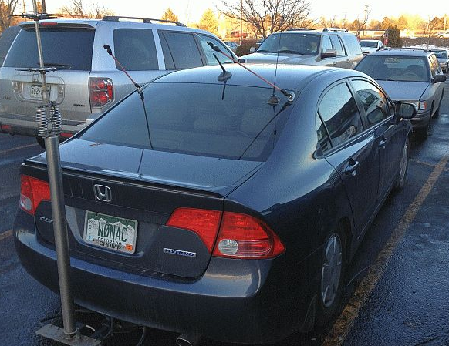 Photo 2 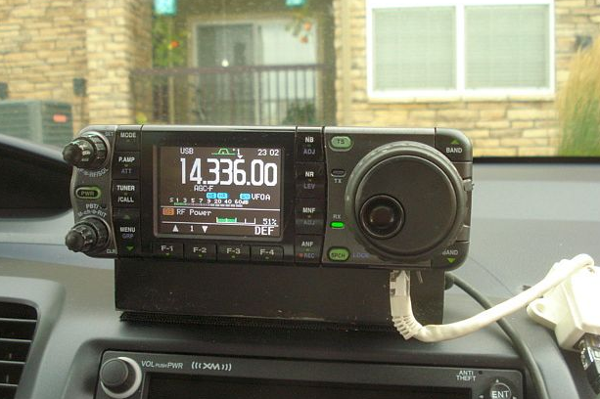
Photo 3 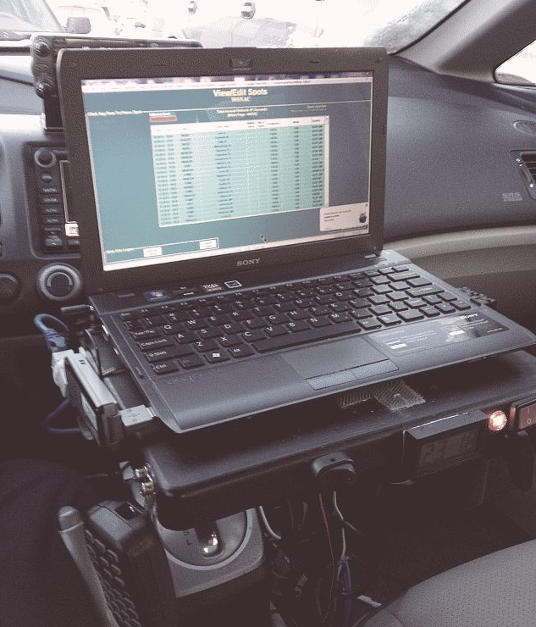 Photo 4 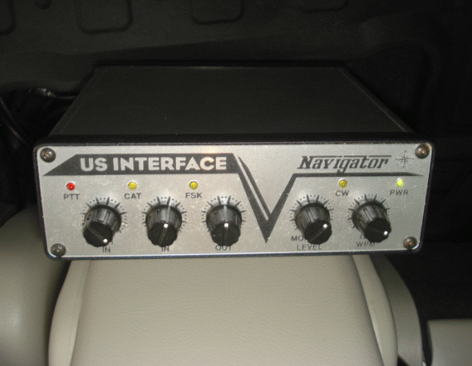

Photo 5 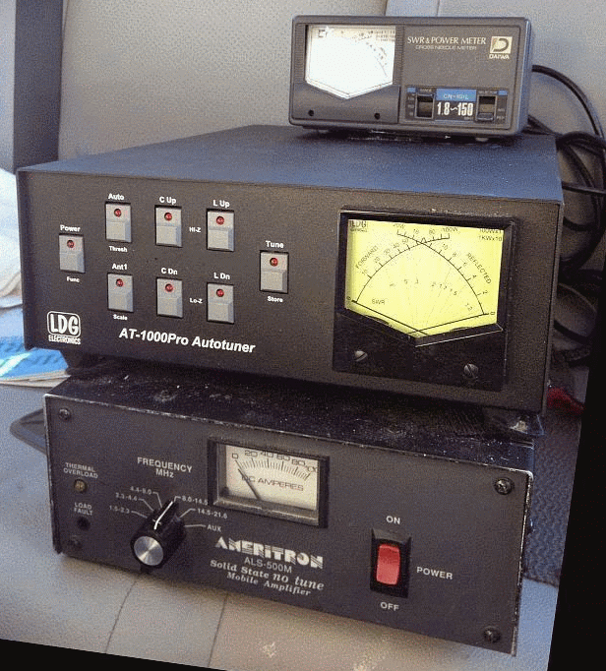 Photo 6 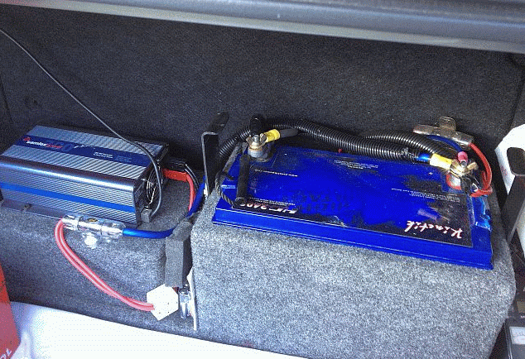

Photo 7 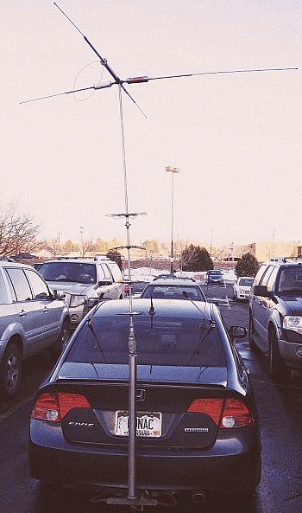

Assuming you are a single operator (team operation will be covered next month), one of the first things you will need to do is plan your route. As noted, I use Delorme Street Atlas for this purpose, but there are other navigation programs which will do this task, but be careful – some programs do not display county lines! Terry (WQ7A) has created a draw object for Street Atlas that displays all county names on the screen. There are 2 versions of this overlay available on the MARAC download site. These are titled “DeLormeCounties.txt” and “DeLormeCountiesCAP.txt” Use the following link to download them - http://www.marac.org/chdownloads .
When planning your route for digital operations, I recommend that you stop on county lines as much as possible. This is more efficient because you will have to stop to operate safely anyway. If the county line is wet or otherwise undesireable to park on, you will need to find a safe place to park for at least 30 minutes. If you have a final destination in mind, you will need to allot at least twice the total time to reach it if putting out counties using digital. Put another way, only plan about ½ the miles or number of counties for any given day. If your final destination is many miles away and you have only a few days to get there, you may not be able to stop on every county line, but only a very few. This is a sure way to get very frustrated!
Before you leave you will also need to check out your macros and be ready to use them. You should plan on spotting yourself in most cases since there is no formal net as yet for helping digital mobiles. This will require wide-area internet coverage of some kind (some now use their smart phones for this purpose). You can also arrange in advance for a fixed station to follow your progress and spot you.
When putting out counties digitally, I recommend that you do so using at least 3 or 4 different modes on just one band (20M). 14074.0 KHz (+/- interference) true frequency is usually a good choice since it is above the 14070-14072 KHz range mostly used by casual PSK operators and is below the 14075 - 14077 KHz range mostly used by JT-65 operators. The four modes we use the most are PSK-63, RTTY, MFSK-16, and THROB-4 (in that order) all transmitted on 14074.0 KHz. Remember, to transmit on this true frequency, set your radio dial to 14.073.0 KHz and the offset on your waterfall to +1000 Hz. If you wish to keep things a bit more simple at first (and also save time), you can limit the modes you use to just one (PSK-63).
TYPICAL SEQUENCE OF EVENTS:
You have done all your homework and planning as outlined above. Now it is time to put out a county line using digital modes. The following is what a typical sequence of events might look like. It can be used as sort of a checklist. Regardless of what is said here, each individual must do what they are comfortable with, so modify it if you wish.
1) Navigate to and stop on the planned county line (or county stopping point).
2) Tune Xcvr dial to 14.0730 MHz and select USB.
3) Tune antenna (if needed) for acceptable SWR.
4) Check that your Fldigi software is running and has the following settings:
a. Configure/Operator:
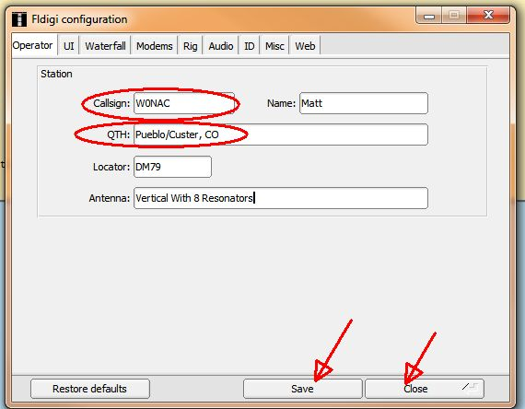
Only the Callsign: and QTH: items are critical to have correct since they are used as TAGS in your
macros. Don’t forget to “Save” before “Closing” this windows. Note: You will need to change the QTH: information each time you move to a new county/county line.
b. Check that OpMode is set to the desired mode.
c. Enter/Modify “Xcvr Freq” (if you want the “freq” box to indicate the true operating frequency).
d. Set waterfall offset to ~ 1000 Hz (move up/down a bit to avoid interfering with other signals if
present)
e. Confirm that proper macro file is open and refresh your memory on what each macro does
5) When ready to go, switch to web spotting site and spot yourself (or have helper spot you).
6) Click on leftmost macro button (Or press the F-1 key) to transmit CQ
7) When another county hunter replies (usually with their call sign 3 times), double click on their call sign to get it into the buffer (it will show in the Fldigi “Call” box near the top of the screen if successful). Then, click on the 2nd (from the left) macro button (Or press the F-2 key). This will acknowledge their call and transmit a standard 599 report.
8) When the calling station acknowledges your 599 report and sends your 599 report back, click on the 3rd macro button from the left (Or press the F-3 key). This will acknowledge receipt of their report, BREAK, and then ask if others wish to call.
9) If another county hunter does call you, then go back to step 7) and repeat.
10) If no one else calls right away, go back to step 6) and repeat your CQ.
11) When you sense that all stations have completed their contacts with you, announce what you are going to do next. Options here include:
a. Changing Mode (Don’t forget to change spot also)
b. Going on to next county line/county
c. Quitting for the day.
12) Drive on to next county line/county.
Please note that the “canned” responses in your macro set are not always appropriate. You may need to respond to non-county hunter calls or questions by using the keyboard to manually type replies. To reply, toggle the transmitter to “ON” by pressing Function Key 12 (F-12) or clicking on the far right macro on the macro line. When finished typing, toggle your xcvr “OFF” by using the same button or key.
OTHER OPTIONS
For logging digital contacts I recommend logging on paper. However, Fldigi has a crude logging capability that some might wish to use. MixW (and other software) has a more capable logging system which can be used with your macros to automatically log contacts which can be later imported into Logger. I have not had time to use this capability yet, but Lloyd (NX4W) uses this method extensively. Please contact him if you need more information on automatic logging using MixW macros. I don’t recommend using the near real time logging capability in Logger as I find it to be too awkward and slow to use, mainly because it requires constant screen switching (multi-tasking), but you may find it to your liking.
You can, of course, use digital modes other than the 4 suggested above. The new 5-Mode award allows using any of 33 approved modes. Of these 33 modes, 26 are considered to be digital modes (CW excluded). If sub-modes are included, one has nearly 100 mode/sub-mode combinations to choose from. However, a few of these modes are not very useful for putting out counties when mobile. For example, JT-65 contacts take 5-6 minutes to complete one short QSO which pretty much rules it out. Even so, there is still a wide variety of modes/sub-mode combinations that are just waiting for someone to try them out.
Putting out counties using digital modes at night is doable, but can be extremely challenging. The lettering on some laptop keyboards are almost impossible to read in the dark. Night mobile operation is NOT for the faint hearted, but don’t let me discourage you. If you do decide to try it, make sure you have a keyboard with high contrast lettering and lighting that allows you to read it.
To sum things up, putting out counties while mobile using digital modes is more difficult than either SSB or CW and the overall contact rate is much slower. However, if you are looking for new challenges and are willing to expand your horizons a bit, I strongly recommend that you give mobile digital a try. Since the early days of county hunting, mobile operators have been the “life blood” for achieving the various awards. The new digital awards are no different in that without the help of mobiles, they will be almost impossible to achieve. With more digital mobiles active, the new digital awards will become attainable.
DIGITAL ACTIVITIES IN DECEMBER
Last month I promised to give you the results of Sharon and my 2 day trip starting the day after Thanksgiving (26 November). The prime purpose of our trip was to get K2MF the WBOW in Hooker County, NE. However, along the way, we planned on putting out 11 county lines (22 total counties) using PSK-63, RTTY, and MFSK-16. We actually put out only a total of 6 county lines (12 total counties) using PSK-63, RTTY and MFSK-16. A summary of the results is given below:

W0NAC/NOLXJ DIGITAL CONTACTS IN CO/NE NOV 26/27 2012
This list is ordered by total number of contacts made with both of us. As you can see, Lloyd (NX4W) and Paul (WB2ABD) top the list followed closely by Dick (N8CIJ), Doug (WA4UNS) and Bill (K5WAF). We thank everyone on the list for their support.
During December I provided advice and support in varying degrees to VK4AAR (Alan), N1API (Al), and K0FG (Fred). I still stand ready to help anyone get started with digital ops. Just email me or call me on the phone. My email is w0nac@comcast.net and my phone number is 303-799-3658. Call any time.
Table 1 has been updated from last month. Again, if I have left anyone off the list you have my sincere apology! Just drop me a quick email and include your stats, if you know them, and I will be pleased to add you to the list. Conversely, if you are on the list and feel that you don’t belong, please also drop me an email and I will remove you.
Logger will currently give you your status for the USA – Digital Award (Go to “View/Edit/Book/USA-Digital/All”), but for the 5-Mode Award, Logger only reports those counties which have been worked using all 5 different modes. You can see this by going to “View/Edit/Book/5-Mode/All”. A fix is still in the works that will report on the status of 1, 2, 3, and 4 completed counties also, but it may be awhile before this is released. While waiting, the 1, 2, 3, and 4 completed county columns for the 5-Mode award will have to remain blank for most folk. Last month I manually computed the completed modes for 2 or 3 people for whom I have fairly recent databases, but couldn’t do it for more (too much work!). However, if you have finished your USA-CA using any mode (or combination of modes), then your 1-Mode completed column number is, by definition, 3077! Here is the updated Table 1:

Next month I plan on discussing “How to operate as a mobile OM/YL team using digital modes”.
Possible topics for the coming months include –
“How to log your digital contacts in Logger”
“How to fine tune your Interface”
“Other Interesting digital modes (JT-65)”

So long again…..Please email me with your comments/suggestions at w0nac@comcast.net and don’t forget to send me your counties worked status on the USA – Digital and 5- Mode awards so I can update the Digital County Hunter Status List again next month.
73’s and we’ll see you down the waterfall,
Matt – W0NAC

