DIGITAL HAPPENINGS #4
(November 2012)
By W0NAC (“Matt”)
I hope none of you ate too much turkey on Thanksgiving! Goodness knows there was plenty to eat at our daughter’s house. After sleeping off my overdose of tryptophan, I had time to reflect on a few of our many blessings. For all of us these include better propagation, falling gasoline prices, cooler weather, and the changing seasons (if you don’t live in Florida or South Texas). Sharon and I have been blessed with relatively good health and a multitude of other things we normally take for granted. God is good!
In the first 3 articles in this series I discussed digital basics (article #1), how to tune and decode digital signals (article #2), and how to adjust your setup for a clean, distortion free transmitted signal (article #3). You may find it useful to review these before going on. This month I will cover, as briefly as I can, how to work with macros and how to go about making your first (of many I hope) QSO using digital modes. You might say that “this is where the rubber meets the road!”

HOW TO CREATE & USE MACROS
First, why do you need to use macros anyway? Sure, it is possible to operate with digital modes using only the keyboard, but unless you are a champion touch typist, you are going to need the help that macros can provide. Take the very popular PSK-31 mode as an example. It transmits at a baud rate of 31.25 which equates to about 50 wpm. PSK-63 (which is becoming more and more popular) doubles this rate to about 100 wpm. Not many of us old “pharts” can type that fast, especially if we use the two finger “hunt and peck” method. Yes, most digital software has a built-in buffer which will wait on your slow typing, but this is a poor solution. For casual rag chews, one can muddle through without using macros, but to have an acceptable QSO rate for county hunting, using macros is essential!
Before getting on with discussing macros, I need to again explain that I cannot (in the space allowed) replace reading the manual. Here are several links to manuals you can use for the fine-grain details:
1) Main Fldigi Manual (by W1HKJ) – 145 Pages - http://www.w1hkj.com/downloads/fldigi/fldigi.pdf
2) Just macros section from same manual - http://www.w1hkj.com/FldigiHelp-3.12/Macros.html
3) More up to date? Edited version of 1) above -185 Pages - http://www.scribd.com/doc/63429517/55/Macros
Everything I discuss in this article will assume that you are using Fldigi software and the SignaLink USB interface. I do this strictly for the sake of brevity and convenience. I have no intention of denigrating any of the other digital software or hardware solutions out there. If you are using different software/hardware you need to give your manuals precedence over anything I say here.
Also, some have asked me what the name “Fldigi” stands for and who created it. Fldigi is short for “Fast Light Digital Modem Application” and is freeware developed by a team of 9 people headed by Dave Freese (W1HKJ).
FLDIGI MACRO FILE STRUCTURE
Fldigi has provision for 4 sets of 12 macros (total of 48) that are contained in files with an .mdf file extension (there can be any number of these files as long as they have different names). These macro files are located in your “$Home” folder as follows:
1) Windows 7 -> “C:\Users\username\fldigi.files\macros”
2) Windows XP -> “C:\Documents and Settings\username\fldigi.files\macros”
You “Open” or “Save” macro files using the drop down menu in the upper left of the screen shown below:
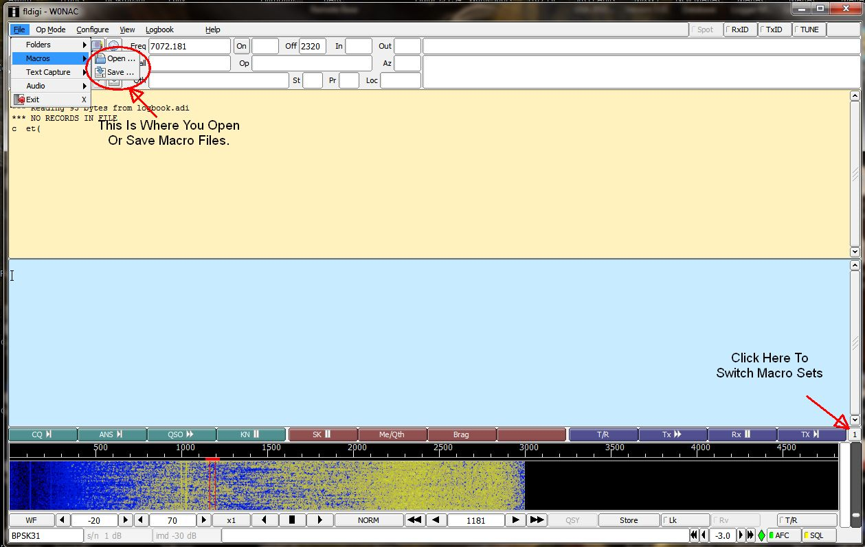
Also, to access each of the 4 macro sets contained in the macro file, left click on the button at the right end of the line of macros to go to set 2, set 3, set 4, etc., OR right click on the same button to scroll backwards. Where you click is shown on the screen above. Also, holding the <Alt> key down while typing 1, 2, 3, or 4 will take you directly to that number macro set.
SAMPLE MACROS
I have created 2 sample macro files which you can use as a departure point for making your own macros. These 2 files can be downloaded from my computer by clicking on the following links:
1) “Casual Fixed.mdf” - https://dl.dropbox.com/u/26171574/Fldigi%20Macros/Casual%20Fixed.mdf
2) “CountyHunter.mdf” - https://dl.dropbox.com/u/26171574/Fldigi%20Macros/CountyHunter.mdf
You should copy both of these files into the Fldigi macro default folder (for your Windows version) listed earlier.
EDITING/SAVING MACROS
After you have opened one of these 2 macro files (I suggest you start by opening the “Casual Fixed” macro file first), you can see the present content (and edit the macro if you need to) by right clicking on the desired macro button. I emphasize right clicking, because a left click is what one uses to execute the macro! The macro button you right click on is shown below:
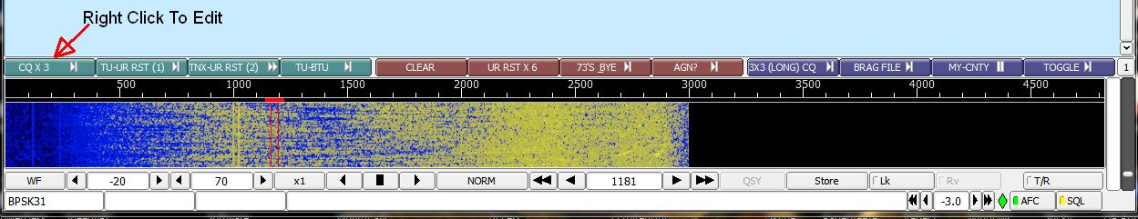
After opening the macro for viewing/editing, you will see the following macro editing window:
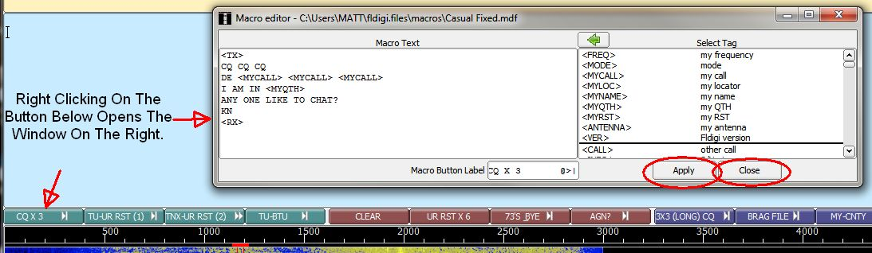
You edit the macro in the left half of the window and “pull in” Tags from the list on the right as desired. Remember, all Tags are in upper case only and are always enclosed with < >‘s.
In the example above the <TX> Tag turns your transmitter ON. The <MYCALL> tag inserts your call sign as stored when you originally configured Fldigi. <MYQTH> inserts your location as typed in when Fldigi was first configured. The final Tag <RX> restores your transceiver to normal receive operation (transmitter OFF).
After editing the macro to do what you wish it to do, click on the “Apply” button to save your changes before closing it. Also, remember to use “File/Macros/Save” to save your changes to the entire macro file.
Look at (and modify if desired) each macro in set #1 for each of the two macro files. You can test them by either left clicking on each one or by pressing their corresponding function key (F-1 through F-12) to execute. Since most of these macros turn the transmitter ON, you may wish to either operate into a dummy load, or turn your TX control all the way OFF before testing. If a macro should get “stuck” ON during testing, press either the <ESC> key or the F-12 key to shut the transmitter off.
This has been a much abbreviated description. For more detail, please refer to one of the manuals listed earlier. If you still can’t figure it out, drop me a line via email and I can probably help.
HOW TO MAKE YOUR FIRST DIGITAL CONTACT
Now for the fun part – making your first QSO using digital modes! Be aware that the majority of hams (non-county hunters) are a garrulous bunch. They really like to “rag chew”! These are the people we are going to try contacting first.
Get ready by having your station set up and thoroughly tested so you know it is working correctly. Then, and only then, do the following:
1) Start Fldigi and “Open” the Casual Fixed macro file.
2) Re-check your Fldigi configuration for the correct call sign, qth, etc.
3) Make sure your transceiver and interface are all ON and configured correctly
4) Set your transceiver dial to 14.070 (USB) and then set your offset (on the waterfall) to somewhere near +1000 Hz in a clear spot where no signals are present.
5) Make sure that your antenna is properly tuned for operating on 14.070 MHz. When you have done all this, your Fldigi screen should look similar to the following:
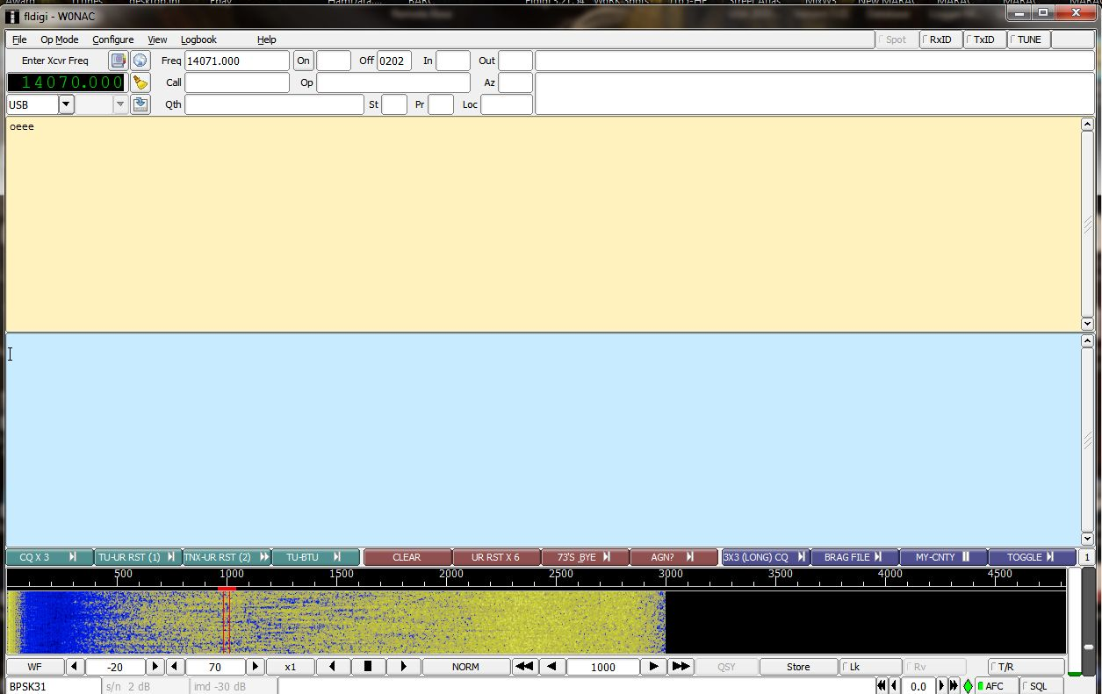
Note that the SQL (squelch) control at the lower right is OFF and AFC is ON.
6) Either press the F-1 key or left click on the CQ X 3 macro button to call CQ. The content of your F-1 macro will be shown as it transmits on the lower (blue) screen as well as echoed to the upper receive screen.
7) After your transmitter switches back to Receive mode, watch for a signal on the waterfall replying to your CQ (normally they will reply on your same frequency). Also, watch for their transmission being decoded in the upper receive window. (When I was just testing this, a JA station came back to me and we completed a short QSO!)
8) When you can see the call sign of the station calling you in the upper receive window, put your mouse pointer on their call sign and double click. If their call sign is embedded in other stray characters, you must highlight just their call sign, right click on it, and then left click on “Call”. Either of these actions places their call sign into the buffer value that is used for the Tag <CALL> used later in macros (their call sign will also be displayed in the “Call” field in the upper part of the screen).
9) To reply with a standard signal report of 599, either press the F-2 key or left click on the 2nd macro button labeled “TU-UR RST (1)” or the 3rd macro button labeled “TNX-UR RST (2)” as appropriate. If they have already given you a signal report, use the 4th macro button labeled “TU-BTU”.
10) If further conversation is in order, just toggle your transceiver ON by using the F-12 key and manually type in what you wish to say. After you have typed in your message and it has been transmitted, press the F-12 key again to turn your transmitter OFF and return to the receive mode.
11) You can use the F-7 macro to sign off if you wish or simply use the F-12 key to transmit and manually type in your closing remarks followed by the F-12 key again to go back to receive.
Congratulations! If you did all this correctly, you have just made your first QSO using digital modes.
Naturally, this is only one possible scenario for a QSO. You may wish to try to answer other stations calling CQ. I have not included a macro for replying to another station’s CQ, but you could easily modify one of the existing macros in “Casual Fixed.mdf” (that you feel you don’t need) for this purpose.
If you want to create your own personalized macro set, I suggest that you simply save an existing macro file to a new file with a different name and then modify the new file to do what you wish it to do. This method will be easier than creating a totally new macro set “from scratch”.
DIGITAL ACTIVITIES IN NOVEMBER
I am writing this on the day after Thanksgiving. Next Monday (26 November) Sharon and I will be setting out on a digital trip into Nebraska and back to Colorado through Wyoming. We plan on putting out 11 county lines (22 total counties) using PSK-63, RTTY, and MFSK-16. Details have been published on the K3IMC site and also emailed to a list of folk who might be interested in working us. I will report on our trip results next month.
Also, I believe I have finished getting VK4AAR (Alan) up and running on digital. He ended up storing his Rascal GLX interface, USB to Serial converter and MISO and replacing them all with a SignaLink USB interface. This seems to have finally cured all the difficulties he had before. I also introduced Alan to JT-65, but this was not his “cup of tea” so that mode is on hold. Sharon and I hope to work Alan on our upcoming trip on at least PSK-63 if not on all three digital modes.
I still stand ready to help anyone get started with digital ops. Just email me or call me on the phone. My email is w0nac@comcast.net and my phone number is 303-799-3658. Call any time.
Table 1 has been updated from last month. Again, if I have left anyone off the list you have my sincere apology! Just drop me a quick email and include your stats, if you know them, and I will be pleased to add you to the list. Conversely, if you are on the list and feel that you don’t belong, please also drop me an email and I will remove you.
Logger will currently give you your status for the USA – Digital Award (Go to “View/Edit/Book/USA-Digital/All”), but for the 5-Mode Award, Logger only reports those counties which have been worked using all 5 different modes. You can see this by going to “View/Edit/Book/5-Mode/All”. A fix is still in the works that will report on the status of 1, 2, 3, and 4 completed counties also, but it may be awhile before this is released. While waiting, the 1, 2, 3, and 4 completed county columns for the 5-Mode award will have to remain blank for most people. I have manually computed the completed modes for 2 or 3 people for which I have fairly recent databases, but couldn’t do it for more (too much work!). However, if you have finished your USA-CA using any mode (or combination of modes), then your 1-Mode completed column number is, by definition, 3077! Here is the updated Table 1:

Next month I plan on discussing ”How to ‘put out’ counties mobile using digital modes”.
Possible topics for the coming months include –
“How to log your digital contacts in Logger”
“How to operate as a mobile OM/YL team using digital modes”
“How to fine tune your Interface”
“Other Interesting digital modes (JT-65)”

So long again…..Please email me with your comments/suggestions at w0nac@comcast.net and don’t forget to send me your counties worked status on the USA – Digital and 5- Mode awards so I can update the Digital County Hunter Status List again next month.
73’s and we’ll see you down the waterfall,
Matt – W0NAC

